


PEMRIG
PARKINSON’S EAST MIDLANDS RESEARCH
INTEREST GROUP
Newsletter – August 2025
Hello to all East Midlands’ people with Parkinson’s and those further afield, their carers, families, health professionals and others reading this August 2025 edition of the PEMRIG newsletter. Please consult the PEMRIG website (https://pemrig.org.uk) for details of past laboratory visits, research seminars and our 2024 Face 2 Face meeting.
PEMRIG is one of thirteen Parkinson’s UK affiliated ‘Research Interest Groups’ around the UK. The aim of the RIGs is to interest People with Parkinson’s, their carers and friends in the exciting Parkinson’s research going on in the UK and all round the world. By following the research, we can see that steady progress is being made to understand and beat Parkinson’s.
To be added to the mailing list for this monthly online newsletter, please contact Liz Nash, PEMRIG’s acting Chair and Research Support Network Lead at Parkinson's UK by email at: l.nash@parkinsons.org.uk

NEWS FROM PEMRIG
LUNCHTIME RESEARCH TALK – NOVEMBER 19th 12.00 to 2.00pm
PEMRIG is delighted to announce that Dr Simon Stott, Head of Research at the Cure Parkinson’s Trust and Dr Kevin McFarthing who maintains the Parkinson’s Hope database of Parkinson’s drugs in trials all round the world, have agreed to speak about the most promising trials in progress at the moment in a lunchtime online seminar date and time as above. Titles of their talks with a link to register for this online seminar will be announced in future newsletters.
PAR-CON 2025 IS GO!
When: October 24th/25th.
WHERE: The Vox Conference Venue, BIRMINGHAM
HOW: Attend free in person or online
The programme will include -
- The latest research updates, including stem cells and new therapies.
- Diet, gut health and nutrition.
- Dealing with mental health challenges
- Living well with Parkinson’s and managing everyday symptoms
- An in-person session organised by our Black, Asian, Arab and mixed heritage support group.
- Plus, taster sessions, a live 2 Parkies in a Pod podcast, conversation with the Movers and Shakers, and much more.
View the draft programme at this link.
Register to attend online or in person at this link.
Editor comments: I attended Par-Con 2024 online and found it a very rewarding experience. The atmosphere was upbeat, everyone seemed to be in good spirits and the talks were of great value especially those offering advice on how to live well with Parkinson’s. I have signed up again hoping that Par-Con2025 will be at least as good as the previous year’s event and hopefully even better. I’m going hoping to hear research is getting us nearer to a new drug to slow/stop/reverse progression……is that too much to hope for? Probably but fingers crossed!

SIGN UP FOR A PARKINSON’S WALK
Parkinson’s UK have organised 15 walks round the UK this summer as part of a keep fit – fund-raising programme. If you are interested in joining in you can find out which of these walks is closest to you by clicking this link.

URGENT - LOCAL TRIAL NEEDS MORE VOLUNTEERS
Title: ‘A placebo-controlled cross-over trial of rhythmic 10Hz median nerve stimulation for the reduction of Parkinson's tremor.’

Who is needed: 60 volunteers with a diagnosis of Parkinson's and a resting tremor in one or both hands/arms.

Where: Department of Psychology, University of Nottingham

How: The trial involves 3-4 visits to determine how an active stimulation compares to a placebo stimulation. You will be randomly allocated into the active or placebo groups but volunteers in the placebo group will be able to try the active stimulation at the end of the trial.

During the first visit researchers will deliver questionnaires to assess your symptoms, tremor and wellbeing. To assess your tremor, a short video will be taken of you and researchers will also give you an accelerometer device to take home for the duration of the trial. This measures your tremor frequency. At the second visit, you will repeat the questionnaires from the first visit and then receive one session of active or placebo stimulation. On your third visit, you will repeat the questionnaires given at the first and second visits. If you are in the placebo group, you will have the opportunity to try the active stimulation during this third visit and be invited back for an additional session. You will also be asked to perform a simple movement task once during your first and last visit and twice during visits where you receive stimulation. The task involves tapping on circles on a screen as fast as you can.

We will offer an inconvenience allowance of £10 per hour, and we will contribute up to £45 per visit to help you with travel expenses for your visit to the University of Nottingham.

For further information about this work please contact: mairi.houlgreave1@nottingham.ac.uk or caitlin.smith1@nottingham.ac.uk. There is no closing date for recruitment, but we will stop recruiting once we have 60 eligible participants.

Editor adds: Mairi says they still need more volunteers……!

RECENT PAST AND FORTHCOMING TALKS ABOUT PARKINSONS
Editor: Apologies, I could only find one new video. It must be holiday time. But it gives you a chance to listen to the advice provided in some of these earlier videos, especially Matthew Phillip’s talk which covers so much ground.

Phillip’s talk which covers so much ground.
I have also found details of a day-long meeting on November 12th about ‘New Approaches to the treatment of Parkinson’s’. I have tried to sign up to attend online but find that it is for professional scientists involved in Parkinson’s research and that they have to pay to attend. Since the day is partly funded by Parkinson’s UK and the Head of Research at PUK is a speaker, it seems odd that any PwP with an interest in research cannot listen in for free. I have complained about this so will report back if I get any response. After all, if it wasn’t for us, these professionals would be in some other line of research! Watch this space!
1, ONE MILLION HITS ……….AND COUNTING!
The originators of the No Silver Bullet 4PD series of videos, Michel and Mark, have just announced that the site has achieved a million hits and more!

To celebrate this huge achievement, they have produced this cheerful extra video which will get your feet tapping along. It can be accessed through this link.
These NSB4PD videos have helped PwP to understand our condition more fully and have allowed us to quiz experts for answers. As Michel and Mark comment on this short video, their YouTube videos have revealed the breadth and depth of the research into Parkinson’s which is in progress around the world. With the knowledge from many of these videos and from our knowledge of trials in progress In the UK and beyond at the moment we can gain some hope that research is closer to a novel treatment that really can slow, stop or reverse progression.

Register for PAR-CON 2025 to hear more about research progress and lots more!

2. CURE INSIGHT – CURE PARKINSON’s SPRING/SUMMER REPORT
Cure Parkinson’s was established in 2005 when four people with Parkinson’s got together and started the Trust because they didn’t think enough was being done to find a cure. Cure Parkinson’s stated mission is to ‘fund and facilitate research that has the potential to cure Parkinson’s. We’re working with urgency to find new treatments that can slow, stop or reverse the condition.’. Make a note to register to hear Simon Stott, Head of Research at Cure Parkinson’s, at PEMRIG’s lunch time seminar in November (see above) to see how the Trust is moving things along.

This half yearly report from the Cure Parkinson’s Trust is a really interesting read.
After a welcome from the CEO Helen Matthews a research section then describes the ASPro-PD trial now underway, explains how a clinical trial is setup and funded, discusses the launch of a new multi-arm clinical trial platform going on in Norway and gives updates on three newly funded projects, one of which is based in Sheffield.
A FUNDRAISING section has a page headed A Question of Time with a video which is accessed via a QR code, describes their 20th anniversary, invites you to Cycle for a cure and much more.
This report can be accessed at this link.

Editor adds: InSight is such an interesting read I suggest you contact Cure Parkinson’s to get your own email copy regularly. To emphasise the ASPro-PD trial in progress I have again included below this updated video from Prof Anthony Schapira who is running this trial.

3. NEW VIDEO RECORDING UPDATE ABOUT PROGRESS ON THE AMBROXOL TRIAL

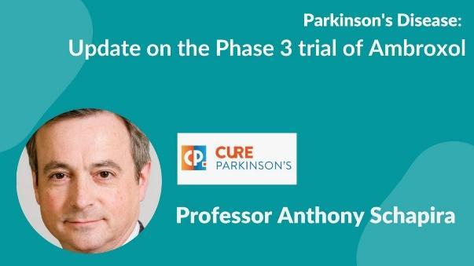
The NSB4PD team are pleased to share this update video by Prof Anthony Schapira on the Phase 3 trial of Ambroxol.

ASPro-PD (Ambroxol to Slow Progression in Parkinson’s) is a Phase 3 clinical trial to assess whether Ambroxol, a cough medicine, can slow or stop the progression of Parkinson’s motor symptoms.

Full details of the Trial can be found on the Cure Parkinson's website here. To watch the recording click on this link.

4. ‘OPTIMISING PARKINSON’S: ESSENTIAL THERAPIES’
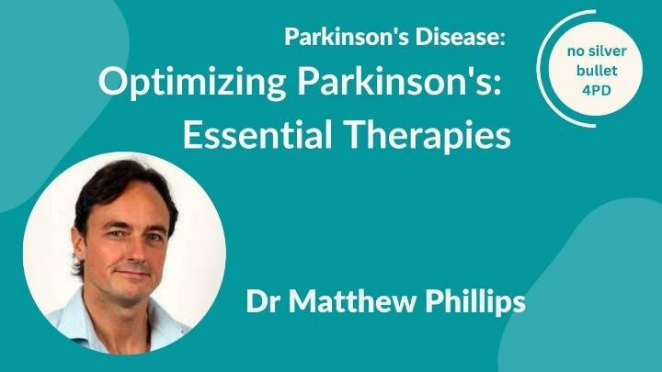
This is the most recent NSB4PD talk. Matthew Phillips is a clinical and research neurologist at Waikato Hospital, Hamilton, New Zealand. His foremost interest is to explore the potential feasibility, safety, and efficacy of metabolic strategies, particularly fasting and ketogenic diets, in creating alternative metabolic states that may benefit people with various neurological disorders. His team conducted the world’s first randomised trials involving a ketogenic diet in people with Parkinson’s and Alzheimer’s disease. Access this talk at this link: https://www.youtube.com/watch?v=3uSKVmYNui8.
Editor adds: This talk provides one consultant’s comprehensive view of different aspects of Parkinson’s, causes due to mitochondrial damage and treatments. Definitely worth listening to but I found Dr Phillips’ rate of delivery far too fast for my poor old Parkinson’s brain to keep up with it all He covers virtually every aspect of the problem, mitohormesis, treatments, diet, spacing ones meals to maximise levodopa uptake, the value of fasting, how to improve sleep, ketogenic diet trials showing improved non-motor effects, stress etc. I tried to take notes, but
my hand was shaking, and I can’t now read what I wrote down, so I am going to have to listen to it again. The questions at the end were very helpful as he spoke slower in answering a specific point.
Please remember that the opinions he expresses about treatments, diet, etc, are his own opinions, Your consultant may have different views!

5. HOW I MANAGE MY SYMPTOMS AIMING TO SLOW DOWN PROGRESSION OF PARKINSON’S DISEASE.
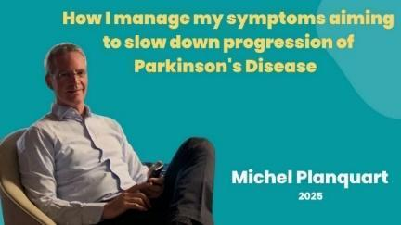
In this short 25 minute You Tube video Michel Planquart describes the strategies he employs to manage his symptoms and hopefully to slow progression of his Parkinson’s. Dealing with his Parkinson’s has become a full-time commitment as Michel describes how he tries to control anxiety, boost his energy levels, clear ‘brain fog’, improve balance, regain his sense of smell, and strengthen his voice and his writing ability.
As he says, time constraints and physical limitations make managing Parkinson’s especially challenging. His goal in sharing his approach is to offer ideas, encouragement and hopefully some inspiration to fellow PwPs. You can access his video here.
Michel emphasises that this video is for informational purposes only and that for medical advice, diagnoses and treatments you should always discuss such topics with your consultant, Parkinson’s nurse or some other qualified healthcare professional.
6. THE LATEST ON CELL REPLACEMENT THERAPIES FOR PARKINSON’S
A recording of this excellent Cure Parkinson’s online seminar is now available at this link.
Editor: I advise watching all the separate recordings from this excellent meeting. which starts with a very clear overview talk by Dr Agnete Kirkeby from Lund University in Sweden. She summarises the whole field of cell replacement therapies. As the Chair of the session remarked, she gave a superb summary of the area suitable for lay and scientific audiences alike.
The comments of the panel in the discussion session comparing DBS, stem cell treatments and gene modification techniques are all especially thought provoking, but all the cell replacement therapies are still many years away from being rolled out as a routine therapy for treating Parkinson’s.

7. TACKLING HALLUCINATIONS AND DELUSIONS IN PARKINSON’S

In this May 4th seminar, a panel of experts discuss what hallucinations and delusions are, how they may affect you and why, how you can manage hallucinations and delusions, and how you can take part in Parkinson’s UK’s-funded TOP HAT and CAN-OP trials about hallucinations and delusions. Unfortunately the recording of the seminar has expired but for more information and support for hallucinations and delusions, please visit the Parkinson’s UK website, here.

PARKINSON’S RESEARCH NEWS

1. TESTING A WELLNESS BEECHBAND

The Editor writes: A few months ago, I got an email about bidding for a free wrist-worn BeechBand wellness device which may help reduce Parkinson’s symptoms., I had tried some of the other devices (eyeline, Cue 1, etc) which claim to improve the tremor associated with Parkinson’s and / or to help with mobility but without any success. Still, as the BeechBand was free and you never know, I ticked the ‘yes please’ box and was successful as the device arrived a few days ago, well packaged in a small very solid cardboard box………so here are some first impressions.

Three A4 sheets of paper come with the device. One of these with the Parkinson’s UK logo top left gives some background to the BeechBand, a second sheet is instructions for charging (USB-C cable not supplied) and using the device and the third page is a survey to be completed, it is suggested, after a couple of weeks testing the BeechBand.

The BeechBand is designed to mimic the rhythmic tapping against his shoulder that Carl Beech found improved his Parkinson’s symptoms – which shoulder and which symptoms are not defined. Anyway, since then Mr Beech has been working with undefined partners to design a wrist-worn device that mimics the tapping sensation that he found improved his symptoms. The BeechBand is stated to be ‘powered’ by Parkinson’s UK which accounts for the PUK logo on the introductory sheet but doesn’t explain what ‘powered by’ means. Has PUK started endorsing some of these devices which some PwP find can improve their symptoms?

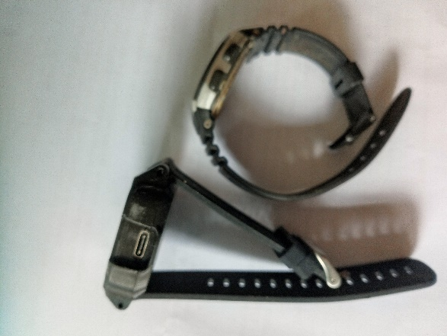
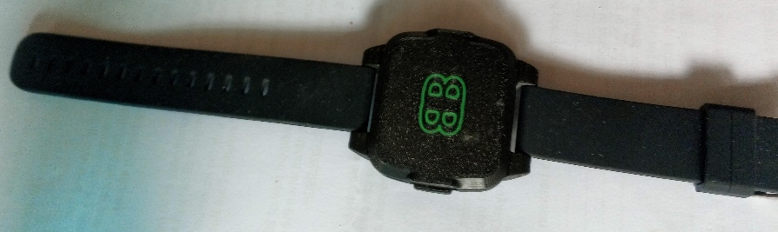
Here are a couple of photos of the device compared (right photo) with my basic Caseo watch. The BeechBand weighs 40g including strap, which isn’t too bad considering my Casio weighs 33g. The BeechBand is bulkier however, extending well over 1cm off my wrist and being approx. 4cm x 4.5cm square. It has a comfy plastic strap.
BeechBand is chunkier than my Casio -top(top)
BeechBand wellness device

I attached a USB-C cable that I had handy and charged the BeechBand for the recommended 45 minutes. When relaxed I don’t usually have much of a tremor or any at all but when stressed it usually shows in my left wrist and hand. So, I attached the BeechBand on the inside of my left wrist and switched on immediately feeling a strong ping sensation every second or so. The time between pings is fixed as is the strength of the ping sensation. In two tests so far, the BeechBand stopped working after 3-3.5 hours because the battery in the device ran out of power and needed recharging which meant unstrapping it from my wrist and plugging into a USB port on my computer for 45 minutes. This interruption every three hiours or so to have to take the watch off and recharge the battery is a bit of a nuisance and battery life clearly needs extending so that the device can be worn for a full day.

Please remember that these are my personal very subjective observations and the very nature of Parkinson’s means that others will respond differently. The battery life of 3 to 3.5 hours should be the same for everyone, however.

2. PARKINSON’s PAPER OF THE MONTH - ‘TRAINED DOGS CAN DETECT THE ODOUR OF PARKINSON’s’

The Editor reports: This short paper appeared recently in the Journal of Parkinson’s Disease and can be accessed by clicking this link.

When I first saw the title of this paper my imagination went into overdrive and I wondered how long it would be before, on going to my yearly appointment with my consultant, I would walk into his office only to find a dog wearing a stethoscope sitting behind the desk reading The Lancet or British Medical Journal. Or worse, that when I was out for a walk a whole pack of dogs would begin following me sniffing and barking. The stuff (sniff?) of nightmares?

Neither scenario is likely at least in the short term though, from this work, the day may well come where a medical professional has a dog which has been trained to detect Parkinson’s with them to aid diagnosis. One bark for yes, two for no! Not likely immediately however, as of the ten dogs initially taken for training in this study to detect Parkinson’s, 5 lacked what is describe as the ‘potential aptitude’, and three ‘failed to learn’ – presumably they hadn’t they made the connection between the distinct smell of sebum from PD and the reward they got for being correct? This left two dogs for advanced training which took 38-53 days. So, 20% of dogs may be suitable for training to sniff out Parkinson’s and the figure may be even lower since the two successful sebum sniffers were a Golden Retriever (dog 1) and a Labrador/Golden Retriever cross (dog 2) both types known for their strong olfactory abilities. But, as is mentioned in the paper, several breeds of dogs have been trained to detect drugs (watch Border Force on TV) and the scent of several human diseases such as prostate cancer, malaria and even Covid -19.

I read that Labrador Retrievers may have a slightly more sensitive sense of smell than Golden Retrievers and interestingly the results of this study reveal that dog 2, the Labrador/Golden Retriever, showed ‘better sensitivity and specificity’ than dog 1, the Golden Retriever. When tested in a double-blind trial using 60 control and 40 target medication-free Parkinson’s skin swabs they both passed with flying colours. In reading the paper I couldn’t find whether the 8 dogs hat didn’t make it were also Golden Retriever/Labrador types or some other breed. Such information may be in the extra information which I haven’t been able to access yet.

The take-home message from this paper is that selected dogs can be trained to detect the odour of Parkinson’s. This observation that some PwP develop a distinct smell all started when Joy Milne, a coauthor on the paper who has hyperosmia, found that she could identify a person with Parkinson’s by smell alone and tests have since proved her right. Detailed chemical studies have taken this work much further revealing that the ‘Parkinson’s ‘odour’ arises from chemical changes (see below) in the waxy sebum secreted by sebaceous glands due to seborrheic dermatitis (SD). According to the Parkinson’s UK website SD is a common skin problem which develops in a considerable proportion of PwP including your editor. I can remember a few years ago when my scalp developed a leathery tight feeling and how it is now scaly, itchy and flaky. My consultant recommended using a shampoo containing 2% ketoconazole (eg Nizoral 2%) twice a week when showering followed by a face cream formulated to treat SD. This all seems to help.

I don’t remember having SD when first diagnosed in 2014 and some years later even though, in an overview of SD on PUK’s website, there is a suggestion that SD may be a premotor feature of PD which is why the smell of Parkinson’s may be useful as a biomarker to spot the condition early on. I sometimes wonder what good receiving such information can do when there is no treatment which can slow, reverse or stop Parkinson’s progression. The PUK’s website page on SD informs that the problem is thought to be due to dysfunction of the autonomic nervous system which also regulates wating and other non-motor symptoms in Parkinson’s such as blood pressure, and the digestive system.

As an ex-lipid biochemist, I was interested to read in related reports that metabolomic studies have identified changes in sphingolipid and arachidonic acid metabolism, the carnitine cycle and fatty acid synthesis in Parkinson’s sebum compared with controls. In a 2019 chemical analysis of Parkinson’s sebum a distinct volatiles-associated signature which includes altered levels of perillic aldehyde and eicosane was reported. It would be interesting to know if these volatiles were what the dogs were detecting in the work above. I would also be interested to know if dogs 1 and 2 lose their ability to detect ‘Parkinson’s odour’ if not regularly reinforced. Also were dogs 1 and 2 detecting the same volatiles? Such experiments are probably in progress right now or were mentioned in the secondary information that I have been unable to access.

PARKINSON’S TRIALS NEEDING VOLUNTEERS
Don’t forget that by volunteering for many of these opportunities you are consenting to your email being shared with the researcher(s) involved in the project.

1. EXPERIENCES OF PEOPLE WITH PARKINSON’S USING MENTAL HEALTH SERVICES.
This trial is open until April 2026. Learn more about what is required by using this link.

2. PARKINSON’S TREATMENT PREFERENCE SURVEY

In this trial you are asked to explain how you feel about the more advanced treatments for mobility issues like DBS. You have to fill in a questionnaire. Closing date is August 15th, 2025 and the researchers hope to get responses from 600 people with Parkinson’s.

Access and join this trial via this link.

3.THE CAN-PDP TRIAL – IS CANABIDIOL AN EFFECTIVE TREATMENT FOR PARKINSON’S PYCHOSES?

About 60% of PwP experience hallucinations - seeing/hearing/feeling things that are not really there. Many also suffer delusions (ie. strange beliefs). Collectively these are known as Parkinson’s psychoses (PDP). The CANnabidiol for Parkinson’s Disease Psychosis trial is a clinical drug trial investigating whether cannabidiol (or CBD) is a safe and tolerable treatment for reducing these psychotic symptoms in PwP. This trial is still open for recruitment in multiple sites across England.

This study is important because the current treatment strategies for PDP are either not very effective, safe, or convenient for everyday use, so, we are looking at cannabidiol (or CBD) as a safer, more tolerable alternative treatment.

More information can be obtained via this link.

4. STEPS 2 - CAN ELECTRICAL STIMULATION IMPROVE WALKING?
Researchers from the Salisbury District Hospital and the University of Plymouth want to understand if a small electrical stimulation device can improve walking for people with Parkinson’s.

Functional Electrical Stimulation (FES) is a technique that applies small electrical impulses through self-adhesive pads. These pads are placed on the skin over nerves that supply muscles that cause the foot to lift. Early testing suggests this may help to retrain movement.

The researchers need to recruit 234 people with Parkinson’s who have difficulty walking due to Parkinson’s, can walk 50 metres with walking aids, and can stand from sitting without assistance from another person.

What is involved?
If you are eligible to take part, you will either receive the study treatment, FES, for 18 weeks or your usual care for 22 weeks. You will be asked to attend visits to your local research site which are at Salisbury, Leeds, Swansea, Birmingham, Bangor or Cumbria.
Those receiving the study treatment, will attend 10 visits and those receiving usual care will attend 6 visits. The length of these visits will vary between 1 and 2 hours during which you will take part in tests to measure your movement, Parkinson’s symptoms, and you will be asked to complete surveys. You will also be asked to complete a falls and exercise diary for the duration of the study. Travel expenses will be reimbursed.
Read the participant information sheet at this link for more information. Then contact the study team by email at steps2.penctu@plymouth.ac.uk.
The deadline for taking part is 31 August 2025. Unfortunately, those receiving Deep Brain Stimulation (DBS) or using other active medical implanted devices, such as a pacemaker, are unable to take part.
5. UNDERSTANDING EMOTION MANAGEMENT AND WELLBEING.
Click here for more information.

CURE PARKINSON’S/PARKINSON’S UK JOINT ‘GET INVOLVED IN RESEARCH’ LEAFLET.
Cure Parkinson’s and Parkinson’s UK have put together a co-branded leaflet with a number of ongoing opportunities to get involved in research for people with Parkinson’s in the UK - click here to access the leaflet.

PARKINSON’S UK RESEARCH SUPPORT NETWORK. This site advertises other trials needing volunteers. So click on the Take Part Hub on the Parkinson’s UK website to find other research projects needing volunteers.
________________________________________________________________________
Newsletter comments, queries, corrections, arguments, and submissions to the Editor (Martin Rumsby) at: martin69747@gmail.com. If you have any top tips for coping with your Parkinson’s, special diets, exercise regimes, etc., that you would like to share with us in this Newsletter, email the editor.
Any mistakes in the details above are entirely the fault of the Editor!

Thanks: The Editor greatly appreciates help from Mia from the PEMRIG steering group with help in proofreading this newsletter and with shortening long links.

Parkinson's UK is registered at 50 Broadway London, City of London, SW1H 0DB, GB and is the operating name of the Parkinson's Disease Society of the United Kingdom. A registered charity in GB (258197), and in Scotland (SC037554).
Parkinson's UK accepts no liability for the content of this email or for the consequences of any actions taken on the basis of the information provided, unless that information is subsequently confirmed in writing. Any views or opinions presented in this email are solely those of the author and do not necessarily represent those of the charity.

