
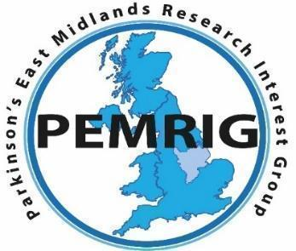

PEMRIG
PARKINSON’S EAST MIDLANDS RESEARCH
INTEREST GROUP
Newsletter – November 2025
Hello to all East Midlands’ people with Parkinson’s and those further afield, their families, health professionals and others reading this November 2025 edition of the PEMRIG newsletter. Please consult the PEMRIG website (https://pemrig.org.uk) for details of past laboratory visits, research seminars and our 2024 Face 2 Face meeting.
PEMRIG is one of thirteen Parkinson’s UK affiliated ‘Research Interest Groups’ around the country. The aim of the RIGs is to interest People with Parkinson’s (PwPs), their carers and friends in the exciting Parkinson’s research going on in the UK and all round the world. By following the research, it is clear that steady progress is being made to understand and beat Parkinson’s.
To be added to the mailing list for this monthly online newsletter, please contact Liz Nash, PEMRIG’s acting Chair and Research Support Network Lead at Parkinson's UK by email at: l.nash@parkinsons.org.uk

PEMRIG NEWS
John Turner 1946-2025
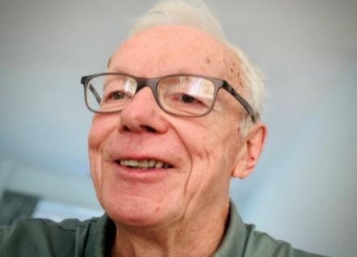
It is with great sadness that the PEMRIG steering group reports the recent passing of our long serving and dedicated Chair, John Turner. John will be sorely missed by the group. He fought a short but cruel illness by aiming to recover and resume his duties on PEMRIG. Alas, this was not to be.
Peter Barrett, a steering group member who knew John better than most of us writes in tribute: “I did not know John for as long as I would have liked, but in the time I did have the privilege of working with him, he made a big impression. Despite his own health problems, he always acted with intelligence, professionalism, tenacity and attention to detail. This was amply demonstrated in his organisation of PEMRIG’s 2024 face to face meeting at Nottingham Trent University which proved to be a great success. He was always aware that his condition would worsen but despite this, he continued to act on behalf of others. In his work he was ably supported by his wife Linda. Her support and care enabled John to do what he loved until the end. His legacy will live on in PEMRIG and we are all the better for knowing him. I’m sure our Parkinson’s community would want to acknowledge our love and respect for a man who gave so much of his life trying to improve that of others.
R.I.P. John”
As Chair of PEMRIG John had, over the years, built up a special relationship with Liz Nash at Parkinson’s UK. She manages the thirteen Research Interest Groups around the UK and writes in tribute:
‘We remember John Turner, a dedicated Parkinson’s UK volunteer and a true inspiration within the Parkinson's community. Diagnosed in 2015, John brought his enthusiasm for research and his experiences as a person with Parkinson's to the task of learning more about the condition and supporting others to get involved and live well.
Following his diagnosis, John became heavily involved in the Parkinson's community. Using his wealth of professional experience as a Chartered Librarian and Team Leader at Nottingham Central Library and Nottingham University, he took a specific interest in Parkinson's research.

He joined the Parkinson’s UK Research Support Network as a Research Champion and Patient and Public Involvement Contributor, and he became an active member of the Parkinson’s East Midlands Research Interest Group (PEMRIG) in 2017. His commitment led him to become Chair of the group not long after, where he fostered an engaging and collaborative environment. John took part in Research studies as often as he could and encouraged researchers and professionals to listen to the needs of people living with Parkinson’s. He was instrumental in planning and delivering several in person and online research and support events, attended by hundreds of people across the East Midlands and further afield.

John was a very special person, warm, knowledgeable, generous and kind. He was a collaborator and a listener, and he has left an incredible legacy to the Parkinson's community that will continue to bring people together in the quest for better treatments and a cure. We will all miss him very much.

Beyond his invaluable contributions to the Parkinson's community, John was a devoted husband, father and proud grandfather, a keen photographer, and a sports enthusiast, particularly cricket’.

On behalf of other members of the PEMRiG steering group, the editor writes:
‘A resounding hear, hear to all the views about John expressed by Liz and Peter above. It has been a privilege to work with John and to be guided by his gentle and common-sense attitude as Chair and to admire his dedication. John’s wife Linda has told me that it was the thought that he might recover to work for PEMRIG again that kept him going through his illness. The fact that PEMRIG is Chairless at the moment says it all. Thank you for the example you have left us, John!’

For those who want to, there is a “Just Giving“ link to the Parkinson’s UK charity in memory of John at https://www.funeralguide.co.uk/obituaries/137487.

SUPPORT PEMRIG BY REGISTERING FOR OUR SECOND LUNCH TIME RESEARCH DISCUSSION ON NOVEMBER 19th. Hear from two leading experts about what drugs are currently being tested in trials to treat Parkinson’s and the latest results.
When: November 19th 12.00 to 2.00pm
Who: Dr Kevin McFarthing and Dr Simon Stott.
Where: Online by zoom. Register for this lunch-time seminar here.
PEMRIG is very grateful that two of the top UK experts on Parkinson’s drugs and drug trials have accepted our invitation to talk at our 2nd lunch time seminar. So, if you want the latest information on how the struggle to discover and test new drugs to treat Parkinson’s is progressing and why progress is so slow and expensive, you should register to attend this meeting.
Trained as a biochemist, Dr Kevin McFarthing’s career has included R&D leadership positions in several life sciences research companies. He now heads the Innovation Fixer Consultancy and annually assembles the Parkinson’s Hope List, a database of potential Parkinson’s therapies in research and clinical stages. He also chairs the PPIE (Patient and Public Involvement and Engagement) group for the EJS ACT (Accelerating Clinical Trials) in Parkinson’s programme. Kevin was diagnosed with Parkinson’s in 2012.
After fifteen years of Parkinson’s research in both the academic and biotechnology sectors Dr Simon Stott is now the Head of Research at the Cure Parkinson’s Trust where, in collaboration with other organisations, he arranges trials for the most promising new Parkinson’s drugs. He also maintains the 'Science of Parkinson's' website, which attempts to explain in plain English what goes wrong in Parkinson’s and what research is currently being conducted to further understand the condition.
Editor adds: Simon Stott’s talks about the latest trials and results always raise my hopes that progress is being made to get new treatments to the clinic.
Programme:
12.00 – Welcome
12.10 - 12.40 - Dr Kevin McFarthing: ‘Where are all the new drugs?’
12.40 - 12.50 - Questions
12.50 - 13.00: Refreshment break
13.00 - 13.35: Dr Simon Stott: ‘Turning trials into therapies.’
13.35 - 13.55: Q & A - both speakers
13.55 - 14.00: Closing thanks.
Questions can be sent in advance by email to: docpete920@gmail.com
_________________________________________________________________________

HOT NEWS – EJS ACT-PD, THE WORLD’S LARGEST CLINICAL TRIAL FOR PARKINSON’S, IS RECRUITING IN LONDON AND NEWCASTLE NOW. RECRUITMENT IN 40 OTHER SITES AROUND THE UK WILL OPEN IN 2026.

FOR MORE INFORMATION SEE THE TRIALS SECTION 3 IN THIS NEWSLETTER. ______________________________________________________________

FORTHCOMING AND RECENT TALKS ABOUT PARKINSON’S
1. MEDICAL CANNABIS AND PARKINSON’S: WHAT YOU NEED TO KNOW
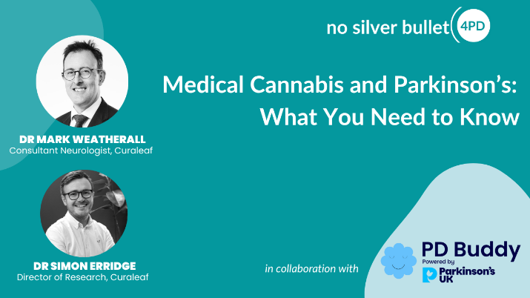
When: November 10th, 7.00pm (London time, GMT)
The NSB4PD community is invited to join PD Buddy for a Q & A session on medical cannabis and Parkinson’s. Beatrice from PD Buddy and Curaleaf experts Drs Mark Weatherall and Simon Erridge will discuss what’s known, what’s safe and what’s next.
They will explore what medical cannabis really means in a clinical setting, including how it differs from recreational use and how cannabinoids like THC and CBD may help manage symptoms like tremor, rigidity, pain, sleep disturbances and mood changes.
The discussion will also cover access routes, dosing forms, safety considerations and which patient profiles benefit most. You will get plain explanations, practical takeaway tips and an opportunity to ask your own questions.
This event is ideal for people with Parkinson’s, carers, clinicians, and anyone interested in understanding how medical cannabis may support movement and quality of life.
The organiser PD Buddy (https://pdbuddy.app/) is a free, comprehensive app for people with Parkinson’s and their carers, offering smart symptom tracking, practical daily management tools, educational

2. REVOLUTIONISING PARKINSON'S TRIAL DESIGN WITH MULTI-ARM, MULTI-STAGE (MAMS) TRIAL PLATFORMS.
The CURE PARKINSON’S autumn update meeting will be discussing this new approach to speeding up the testing of drugs which may slow, stop or even reverse the progression of Parkinson’s. If you plan to sign up as a volunteer on the EJS ACT-PD trial just starting to recruit, this meeting should give a good introduction.
WHEN: November 10th, 2.00pm to 5.00pm
Book your place online at this link.
Programme:
2pm - 2:05pm: Helen Matthews, CEO Cure Parkinson’s, Welcome and opening remarks
2.05pm – 2.30pm: Dr Simon Stott, Director of Research, Cure Parkinson’s. Looking forward: Cure Parkinson’s Research Strategy +Q&A
2:30pm – 3.15pm. SLEIPNIR: Prof Charalampos Tzoulis, University of Bergen
3:15pm - break3:45pm – 4.00pm. Dr Chirine Katrib, France Parkinson. International MAMS Consortium: Coordinating Parkinson’s trials worldwide
4:00pm – 4.30pm. Georgia Mills, Research Project Manager, UCL. EJS ACT-PD: how to get involved.

4:30pm - Panel discussion: Participating In and Shaping Parkinson’s Research.
Dr Kevin McFarthing and Michèle Bartlett, Co-Chairs of the EJS ACT-PD PPIE Working Group
Interviewer: Dr Simon Stott, Director of Research, Cure Parkinson's

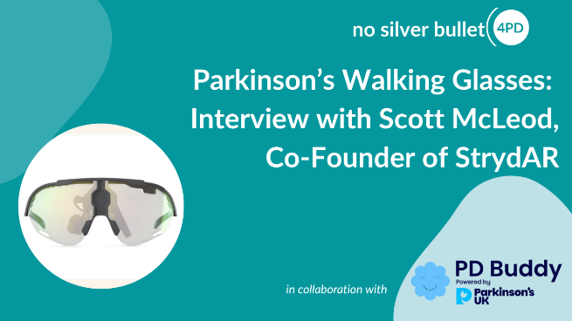
3. Parkinson’s Walking Glasses: PD Buddy interview with Scott McLeod, Co-Founder of StrydAR – a new recording.

In collaboration with the PD Buddy app, this interview features Scott McLeod, co-founder of StrydAR, who discusses StrydAR’s groundbreaking Parkinson’s Walking Glasses. These innovative glasses use visual cueing technology, inspired by fighter-pilot helmets, to help people with Parkinson’s overcome mobility challenges such as freezing of gait, slowness, and balance issues.
The interview explores how the holographic cue works, which symptoms it targets, and how quickly users notice improvements in walking, posture, and confidence. Scott also explains when and how to use the glasses, whether prescription lenses are needed, and provides details on cost and trial options.
For anyone living with Parkinson’s, or supporting someone who is, this interview offers practical insight into an innovative tool designed to make everyday life safer, easier, and more independent.The following 2 min 40 sec feature on Scottish TV provides a helpful introduction to the topic: https://youtu.be/nHGr80SnLIU?si=b43EWFD8iLxrB0Tt
Watch the full recording here.

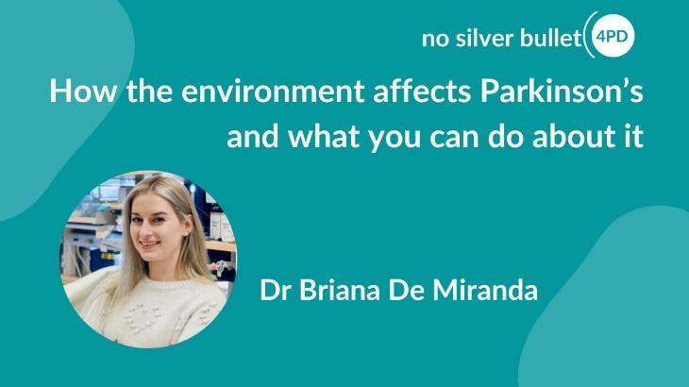
4. HOW THE ENVIRONMENT AFFECTS PARKINSON’S AND WHAT YOU CAN DO ABOUT IT.
The topic of this talk is highly relevant to those of us with the sporadic (idiopathic) form of Parkinson’s since exposure to some sort of environmental factor years before diagnosis, may have been the trigger which initiated the disease process. Dr De Miranda is a neurotoxicologist, and her interdisciplinary research is aimed at understanding how neurodegeneration is caused by environmental exposures and finding ways to treat or prevent neurologic disorders caused by toxic risk factors.
You can access a recording of her talk at this link.

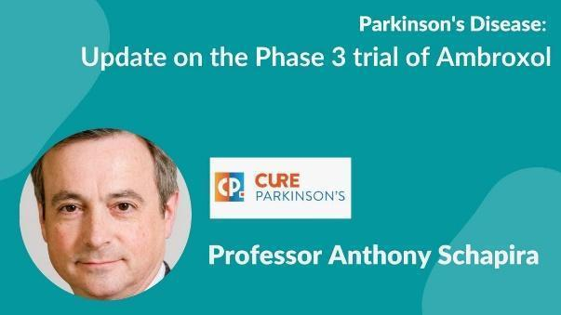
5. NEW VIDEO RECORDING UPDATE ABOUT PROGRESS ON THE AMBROXOL TRIAL
To emphasise the ASPro-PD trial in progress I have again included this updated video from Prof Anthony Schapira

ASPro-PD (Ambroxol to Slow Progression in Parkinson’s) is a Phase 3 clinical trial to assess whether Ambroxol, a cough medicine, can slow or stop the progression of Parkinson’s motor symptoms.

Full details of the Trial can be found on the Cure Parkinson's website here.
To watch the recording click on this link.
6. PAR-CON 2025
This event will be over by the time you get this newsletter. If you missed the event or want to catch up with any of the talks again click on this link:
https://url3073.emma-live.com/ls/click?upn=u001.U4hJGmdasqn-2FIoNZwi3s6wuoIYuiQl9hBor14m1JpbUZ6H4P4Me1OxccfH5fbbknGPdRq9rbBmbZgtnALBSps6juptW-2Fh7uLF8eSD9IOIbhY6yJUd-2BowfSoul6znLINQa1Uw_57h41kPk7SOOnqHiB5xFXOhVe-2BJ2p5abypGMU98Tiu4o0OD9jIKzrcGdlBPQMAyWj3NNN97g984Zti831Xqy-2FWnlWg-2FBh8N8-2Fcxk47QWGYxuwc8DUbqyI9dKx8ie-2BHmlD6u9RTjdZLCvHvsE-2F30ZyYQKtNVoE-2B3MIQ1pnqgVo3NS7z1xb-2BvmqwQkZeYMT4aLwqlYhsFTzJOmvmcWqdxrn4IYm5uGvxake9wz-2B7X7FmAKumLadWxiaZXgNxf04-2BraiHlU7DK3nw5BgWCGZa7vr-2F-2BjFkPDLd8nzK-2B06F7TdHqHI23C0JAYyUEYw8zsubpvvLJhKC1rR0A6tpzJaN1HDi6uA5ZQ15Nq-2B-2FUs3POBqFYYa5ZphYuzzMsbAA718rxTNIZM-2FIdsvmssK3v-2BhZDiaPX0eeTABop9DE-2B0NCbqX-2FQ-3D
PARKINSON’S RESEARCH NEWS
1. BeechBand testing
Nothing new to report and no more accounts of user’s experiences from my Parkinson’s nurse. As reported last month a new version of the BeechBand , the 100D model, with quieter motor and strap without a buckle is available from November 10th for £54.50.

The link to the BeechBand site with some success stories is here.

2. α-SYNUCLEIN
The editor has spotted two interesting papers on this critically important protein which is believed to contribute to dopaminergic nerve cell death in Parkinson’s. These reports are both discussed in lay terms in the October 21st edition of Parkinson’s News Today.

To recap, a-synuclein (aSYN) accounts for 1% of the total protein of neurones in the CNS. It is abundant at presynaptic terminals and normally plays a role in regulating synaptic vesicle trafficking, exocytosis, vesicle fusion and neurotransmitter release. Normally, aSYN exists as an intrinsically disordered monomer but under pathological conditions it misfolds and aggregates to form nanoscale oligomers which interfere with normal cell function. These misfolded nanoscale oligomers aggregate further to form the Lewy bodies which are toxic to neurones, causing the death of dopaminergic neurones. It is believed that aSYN oligomers released from dying neurones can be taken up by nearby healthy neurones, propagating the death of neurones.

In a report (1) entitled ‘Large-scale visualization of α-synuclein oligomers in Parkinson’s disease brain tissue’ post-mortem Parkinson’s brain tissue has been analysed against control tissue to detect and quantitate the nanoscale aSYN oligomers that are present. The researchers used a novel fluorescence microscopy method which for the first time allows visualisation of these nanoscale oligomers. Not unexpectedly, the results revealed that higher levels of aSYN oligomers were detected in the Parkinson’s brain tissue compared with control tissue. The fact that aSYN oligomers were detected in healthy brain tissue shows that oligomer formation occurs naturally but that in Parkinson’s some event causes abnormal oligomer formation.
1. Andrews, R., Fu, B., Toomey, C.E. et al. Large-scale visualization of α-synuclein oligomers in Parkinson’s disease brain tissue. Nat. Biomed. Eng (2025). https://doi.org/10.1038/s41551-025-01496-4

WTX-607. The second report of interest deals with the successful preclinical testing of a drug which blocks the formation of aSYN oligomers. WTX-607 is an oral small molecule being developed by a company called Wavebreak. WTX-607 binds to and blocks the formation of aSYN oligomers in cell and animal models at the earliest step in the process of oligomer formation – this is the nucleation step when single aSYN molecules bind together. Inhibiting nucleation should reduce the spread of toxic aSYN aggregates between nerve cells, potentially slowing disease progression in Parkinson’s and Lewy body dementia, and restoring cognitive function.

Wavebreak presented their exciting new results at this year’s International Congress of Parkinson’s Disease and movement disorders held in Honolulu. The results of studies with models of PD and Lewy body dementia showed that WTX-607 slowed disease progression and improved cognitive function. Earlier lab studies have shown that WTX-607 can inhibit up to 93% of primary nucleation, the process by which single aSYN protein molecules form oligomers, and up to 95% of secondary nucleation, in which existing aggregates of aSYN act as seeds that promote new clump formation. Wavebreak believe that their results with WTX-607 support its transition to clinical testing. Of course, it will be many years before such a compound reaches the clinic but it is good to know that a drug which prevents aSYN nucleation and aggregate formation is being tested.
The presentation about WTX-607 is available on WaveBreak's website, here.
PARKINSON’S TRIALS NEEDING VOLUNTEERS
(Don’t forget that by volunteering for many of these opportunities you are consenting to your email being shared with the researcher(s) involved in the project).

1. Edmond J Safra Accelerating Clinical Trials in Parkinson’s (EJS ACT-PD), the world’s largest clinical trial for Parkinson’s, is now recruiting in the London and Newcastle areas. By mid-2026 all 40 sites should be open for recruiting. Cure Parkinson’s and Parkinson’s UK are both involved in funding this new multi arm multi stage (MAMS) platform in which several drugs are tested against one placebo compound and where a drug that is observed to be ineffective can be withdrawn and replaced by a new drug. To get a thorough explanation sign up for the Cure Parkinson’s discussion of the EJS ACT-PD afternoon seminar from 2.00pm on November 10th - see above. Alternatively, click on this link to go to the Cure Parkinson’s E-newsletter where there is a full description.

Alternatively, you could use this link to the Parkinson’s UK description of the trial. There is a button to click to register your interest.

Overall, the trial will need 1600 volunteers and is costing something like £29 million. The Parkinson’s UK link above sets out the requirements and includes a form to register your interest even though most local centres haven’t started recruiting yet. This is a great chance to get involved in a new big trial. The first two repurposed drugs being tested are terazosin and telmisartan both being in the final Phase 3 stage of testing. A third compound, ursodeoxycholic acid will be added in 2026.

2. WHAT DO YOU THINK ABOUT BRAIN STIMULATION THERAPIES?
Researchers at the University of Nottingham want to understand how people with Parkinson’s view using brain stimulation therapies. These therapies include Deep Brain Stimulation (DBS), focused ultrasound, nerve stimulation and more. Your opinions will help researchers develop non-drug approaches to treating Parkinson’s.

Who is needed: 1000 people with Parkinson’s

What is involved? Completing a 10-to-20-minute online survey in which you will be asked about your Parkinson’s symptoms and your thoughts on different brain stimulation therapies.

For more information, please read the participant information sheet.

If you need support completing the survey, please contact the researchers by email by email at caitlin.smith1@nottingham.ac.uk or isabel.farr1@nottingham.ac.uk.
The deadline for taking part in this research is 1 March 2026.

3. SUPPORTING DECISION MAKING IN PARKINSON’S

Hannah Kisley, a PhD student at University College London, wants to improve how PwP, their partners and family members are supported when they need to make difficult decisions about future care and support.

Hannah needs to work with PwP to make sure her research reflects their experiences and focuses on what matters most to them.

Who is needed: People with Parkinson’s and their carers.

What is involved: You will join an advisory group which will ensure that the project is relevant, inclusive and deals with what matters most to people living with Parkinson’s and those who support them.

You can get involved from home in a way that suits you by email, phone, or by joining an online group meeting. Hannah will offer support to help you join a video call. You will be offered payment for your time. Read our guidance on payments on our website.]

If you’ve got any questions, or if there are ways Hannah can support you to get involved, contact her via email at hannah.kisley.23@ucl.ac.uk or by phone on 02039 872 372.

4. DOES EXERCISE BUILD RESILIENCE IN PEOPLE WITH PARKINSON’S?
A PhD student wants to understand how exercise affects the resilience of people with Parkinson’s. The student is keen to learn how exercise may help PwP feel stronger and how it can improve their quality of life. This research will also explore what type of exercise people with Parkinson’s prefer. This trial is based at the Medical School in Derby Royal Hospital so is very convenient for PwP in the Derby area.
Who is needed: 16 people with Parkinson’s who are over 40 years old, can walk 30m with or without a walking aid and can travel to Derby Medical School. Sorry but anyone with a diagnosis of dementia or any other neurological conditions is ineligible.
Where: The study is based at the Medical School in Derby Royal Hospital so is very convenient for PwP in the Derby area.

What is involved:
- Travel to Derby Royal for two study visits, the first involving an hour’s screening for the study
- The second visit will last 3.5 hour including breaks and you will complete assessments of your strength, balance and flexibility,
- On this second visit you will take part in cycling or walking at a moderate pace for 40 minutes.
You will be paid £150 for travel expenses and for taking part in the study. Parking spaces will be provided for anyone coming by car and members of the research team will provide help with Turkish, Arabic, Portuguese and Mandarin if needed. A supporter may attend the study visits if necessary.
For more information read the participant information sheet.
To take part email Mehmet at: Mehmet.cagatay.yildirim@nottingham.ac.uk or sign up here.
5. A PLACEBO-CONTROLLED CROSS-OVER TRIAL OF RHYTHMIC 10HZ MEDIAN NERVE STIMULATION FOR THE REDUCTION OF PARKINSON'S TREMOR.

Who is needed: 60 volunteers with a diagnosis of Parkinson's and a resting tremor in one or both hands/arms.
Where: Department of Psychology, University of Nottingham.

How: The trial involves 3-4 visits to determine how an active stimulation compares to a placebo stimulation. You will be randomly allocated into the active or placebo groups but volunteers in the placebo group will be able to try the active stimulation at the end of the trial.

During the first visit researchers will deliver questionnaires to assess your symptoms, tremor and wellbeing. To assess your tremor, a short video will be taken of you and researchers will also give you an accelerometer device to take home for the duration of the trial. This measures your tremor frequency. At the second visit, you will repeat the questionnaires from the first visit and then receive one session of active or placebo stimulation. On your third visit, you will repeat the questionnaires given at the first and second visits. If you are in the placebo group, you will have the opportunity to try the active stimulation during this third visit and be invited back for an additional session. You will also be asked to perform a simple movement task once during your first and last visit and twice during visits where you receive stimulation. The task involves tapping on circles on a screen as fast as you can.

We will offer an inconvenience allowance of £10 per hour, and we will contribute up to £45 per visit to help you with travel expenses for your visit to the University of Nottingham.

For further information about this work please contact: mairi.houlgreave1@nottingham.ac.uk or caitlin.smith1@nottingham.ac.uk. There is no closing date for recruitment, but we will stop recruiting once we have 60 eligible participants.

Editor adds: Mairi says they still need more volunteers……!
6. EXPERIENCES OF PEOPLE WITH PARKINSON’S USING MENTAL HEALTH SERVICES.
This trial is open until April 2026. Learn more about what is required by using this link.

7.THE CAN-PDP TRIAL – IS CANABIDIOL AN EFFECTIVE TREATMENT FOR PARKINSON’S PYCHOSES?

About 60% of PwP experience hallucinations - seeing/hearing/feeling things that are not really there. Many also suffer delusions (ie. strange beliefs). Collectively these are known as Parkinson’s psychoses (PDP). The CANnabidiol for Parkinson’s Disease Psychosis trial is a clinical drug trial investigating whether cannabidiol (or CBD) is a safe and tolerable treatment for reducing these psychotic symptoms in PwP. This trial is still open for recruitment in multiple sites across England.

This study is important because the current treatment strategies for PDP are either not very effective, safe, or convenient for everyday use. So, we are looking at cannabidiol (or CBD) as a safer, more tolerable alternative treatment. More information can be obtained via this link.

8. UNDERSTANDING EMOTION MANAGEMENT AND WELL BEING.
Click here for more information.

CURE PARKINSON’S/PARKINSON’S UK JOINT ‘GET INVOLVED IN RESEARCH’ LEAFLET.
Cure Parkinson’s and Parkinson’s UK have put together a co-branded leaflet with a number of ongoing opportunities to get involved in research for people with Parkinson’s in the UK - click here to access the leaflet.

PARKINSON’S UK RESEARCH SUPPORT NETWORK. This site advertises other trials needing volunteers. So click on the Take Part Hub on the Parkinson’s UK website to find other research projects needing volunteers.
________________________________________________________________________
Newsletter comments, queries, corrections, arguments, and submissions to the Editor (Martin Rumsby) at: martin69747@gmail.com. If you have any top tips for coping with your Parkinson’s, special diets, exercise regimes, etc., that you would like to share with us in this Newsletter, email the editor.
Any mistakes in the details above are entirely the fault of the Editor!

Thanks: The Editor greatly appreciates help from Mia from the PEMRIG steering group with help in proofreading this newsletter and with shortening long links.

Parkinson's UK is registered at 50 Broadway London, City of London, SW1H 0DB, GB and is the operating name of the Parkinson's Disease Society of the United Kingdom. A registered charity in GB (258197), and in Scotland (SC037554).
Parkinson's UK accepts no liability for the content of this email or for the consequences of any actions taken on the basis of the information provided, unless that information is subsequently confirmed in writing. Any views or opinions presented in this email are solely those of the author and do not necessarily represent those of the charity.

