PEMRIG
PARKINSON’S EAST MIDLANDS RESEARCH
INTEREST GROUP
Newsletter – October 2025
Hello to all East Midlands’ people with Parkinson’s and those further afield, their families, health professionals and others reading this October 2025 edition of the PEMRIG newsletter. Please consult the PEMRIG website (https://pemrig.org.uk) for details of past laboratory visits, research seminars and our 2024 Face 2 Face meeting.
PEMRIG is one of thirteen Parkinson’s UK affiliated ‘Research Interest Groups’ around the country. The aim of the RIGs is to interest People with Parkinson’s (PwPs), their carers and friends in the exciting Parkinson’s research going on in the UK and all round the world. By following the research, it is clear that steady progress is being made to understand and beat Parkinson’s.
To be added to the mailing list for this monthly online newsletter, please contact Liz Nash, PEMRIG’s acting Chair and Research Support Network Lead at Parkinson's UK by email at: l.nash@parkinsons.org.uk

PEMRIG NEWS
Learn about THE LATEST PARKINSON’S DRUGS AND DRUG TRIALS while you have your lunch.
When: November 19th 12.00 to 2.00pm


Who: Dr Kevin McFarthing and Dr Simon Stott.
Where: Online by zoom. Register for this seminar here.
PEMRIG is very grateful that two of the top UK experts on Parkinson’s drugs and drug trials have accepted our invitation to talk at our 2nd lunch time seminar. So, if you want the latest information on how the struggle to discover and test new drugs to treat Parkinson’s is progressing and why progress is so slow and expensive, you should register to attend this meeting.
Trained as a biochemist, Dr Kevin McFarthing’s career has included R&D leadership positions in several life sciences research companies. He now heads the Innovation Fixer Consultancy and annually assembles the Parkinson’s Hope List, a database of potential Parkinson’s therapies in research and clinical stages. He also chairs the PPIE (Patient and Public Involvement and Engagement) group for the EJS ACT (Accelerating Clinical Trials) in Parkinson’s programme. Kevin was diagnosed with Parkinson’s in 2012.
After fifteen years of Parkinson’s research in both the academic and biotechnology sectors Dr Simon Stott is now the Head of Research at the Cure Parkinson’s Trust where, in collaboration with other organisations, he arranges trials for the most promising new Parkinson’s drugs. He also maintains the 'Science of Parkinson's' website, which attempts to explain in plain English what goes wrong in Parkinson’s and what research is currently being conducted to further understand the condition.
Editor adds: Simon’s talks about the latest trials and results always raise my hopes that progress is being made to get new treatments to the clinic.
Programme:
12.00 - Welcome
12.10 - 12.40 - Dr Kevin McFarthing: ‘Where are all the new drugs?’
12.40 - 12.50 - Questions
12.50 - 13.00: Refreshment break
13.00 - 13.35: Dr Simon Stott: ‘Turning trials into therapies.’
13.35 - 13.55: Q & A - both speakers
13.55 - 14.00: Closing thanks.
Questions can be sent in advance by email to: docpete920@gmail.com

PAR-CON 2025 IS GO!
When: The 24th and 25th of October 2025.
Where: The Vox Conference Venue, Birmingham
How: Attend free in person or online
The programme will include -
- The latest research updates, including stem cells and new therapies.
- Diet, gut health and nutrition.
- Dealing with mental health challenges
- Living well with Parkinson’s and managing everyday symptoms
- An in-person session organised by our Black, Asian, Arab and mixed heritage support group.
- Plus, taster sessions, a live ‘2 Parkies in a Pod’ podcast, conversation with the Movers and Shakers, and much more.
View the draft programme at this link.
Register to attend online or in person at this link.
Editor comments: I attended Par-Con 2024 online and found it a very rewarding experience. The atmosphere was upbeat and the talks were of great value especially those offering advice on how to live well with Parkinson’s. I have signed up again hoping that Par-Con2025 will be at least as good as the previous year’s event and hopefully even better. I’m going hoping to hear research is getting us nearer to a new drug to slow/stop/reverse progression……is that too much to hope for? My fingers are crossed!

FORTHCOMING AND RECENT TALKS ABOUT PARKINSON’S
1. ‘HOW THE ENVIRONMENT AFFECTS PARKINSON’S AND WHAT YOU CAN DO ABOUT IT!’
When: October 6th, 7.30pm
Where: Online
Speaker: Dr Briana de Miranda
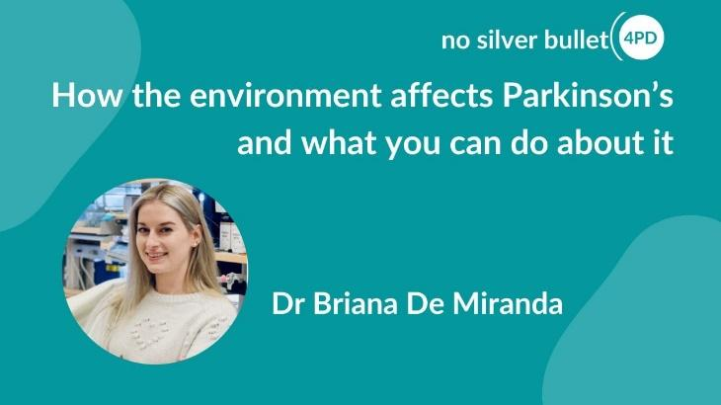
This talk, the next in the NSB4PD series, is highly relevant to those of us with the sporadic (idiopathic) form of Parkinson’s since exposure to some sort of environmental factor years before diagnosis, may have been the trigger which initiated the disease process.

Briana De Miranda, Ph.D., is a Neurotoxicologist and Associate Professor of Neurology in the Killion Centre for Neurodegeneration at the University of Alabama at Birmingham. Her research focuses on environmental risks for neurodegenerative diseases, integrating expertise in toxicology, pharmacology, and neuroscience. Her interdisciplinary research is aimed at understanding how neurodegeneration is caused by environmental exposures and finding ways to treat or prevent neurologic disorders caused by toxic risk factors.
Register to hear this webinar at this link.

2. 'The Parkinson's Brain Bank,'

The West of Scotland Research Interest Group recently hosted a very informative webinar about the Parkinson’s Brain bank. The importance of the Parkinson’s brain bank as a resource for research is stressed and examples given of studies using brain bank tissue. The way in which tissue is taken to the brain bank, the stage of disease analysed and how the tissue is fixed with formalin or by freezing is described. The importance of having control tissue from matched healthy people available for research as control tissue is emphasised. We heard that the supply of tissue for experiments is carefully decided by a committee. Click here to hear the talk.

There is more information about the Parkinson’s Brain Bank and a podcast by ‘The Two Parkies in a Pod’ about their visit to the Brain Bank in this month’s Research Roundup from Parkinson’s UK. The link to the Research Roundup is the first item in the Research Section below.
3. EDINBURGH PARKINSON’S LECTURE 2025
The Edinburgh Parkinson’s Lecture is a flagship event for the Parkinson’s community to hear about progress to understand and treat the condition.

When: Thursday, 2 October 19.10-20.45 BST

Speaker: Dr Agnete Kirkeby -
Agnete Kirkeby is an Associate Professor at the Novo Nordisk Foundation Centre for Stem Cell Medicine (reNEW), University of Copenhagen, Denmark. Together with collaborators from Lund University, University of Cambridge and Novo Nordisk, Dr. Kirkeby has developed a stem cell-based dopamine cell product for treatment of Parkinson’s Disease (STEM-PD), which entered clinical trial in 2023 in Sweden and the UK for treatment of individuals with moderate Parkinson’s. Dr. Kirkeby and her group also work on the preclinical development of stem cell therapies for treatment of dementia symptoms in PD as well as on using stem cell models for identifying novel drugs for inhibiting the progression of the pathological processes at work in Parkinson’s.

Use this link to get more information about this lecture and to register for online attendance.
4. INTERVIEW WITH CARL BEECH ABOUT THE WELLNESS BEECHBAND
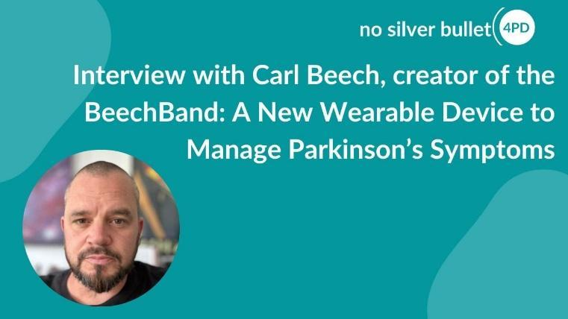
In this webinar from September 8th the NSB4PD team interviewed Carl Beech, inventor of the BeechBand, a discreet, wrist-worn device designed to help people with Parkinson’s manage tremor, slowness, and stiffness. Backed by funding from Parkinson’s UK and praised for its simplicity, this innovative wearable device is gaining attention across the Parkinson’s community.

In this webinar Carl Beech answers questions and describes his journey from idea to impact, how the BeechBand works and what users are saying so far. If you missed this session with Carl Beech the first time around, you can hear it again at this link.

Editor: I have just trialled the current model of the BeechBand. I discuss the BeechBand and other webinars from Carl Beech in the research section below.
5. A CHANGE IN APPROACH FOR PARKINSON’S RESEARCH -COMBINATION THERAPIES.
The latest copy of Cure Parkinson’s e-newsletter has an interesting article about how they are seeking to progress research with combination therapies as a potential method for impacting Parkinson’s progression. Cure Parkinson’s are championing the testing of combination therapies with the hope of identifying disease-modifying therapies with urgency. To kick-start this, Cure Parkinson’s will be opening a £2 million funding call in October 2025 to encourage testing of combination therapies for Parkinson’s.
Read the article at this link.
6. NEW VIDEO RECORDING UPDATE ABOUT PROGRESS ON THE AMBROXOL TRIAL

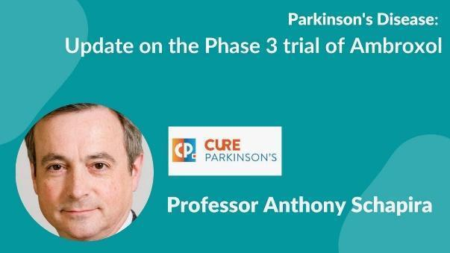
To emphasise the ASPro-PD trial in progress I have again included this updated video from Prof Anthony Schapira

ASPro-PD (Ambroxol to Slow Progression in Parkinson’s) is a Phase 3 clinical trial to assess whether Ambroxol, a cough medicine, can slow or stop the progression of Parkinson’s motor symptoms.

Full details of the Trial can be found on the Cure Parkinson's website here.
To watch the recording click on this link.

7. ‘OPTIMISING PARKINSON’S: ESSENTIAL THERAPIES’
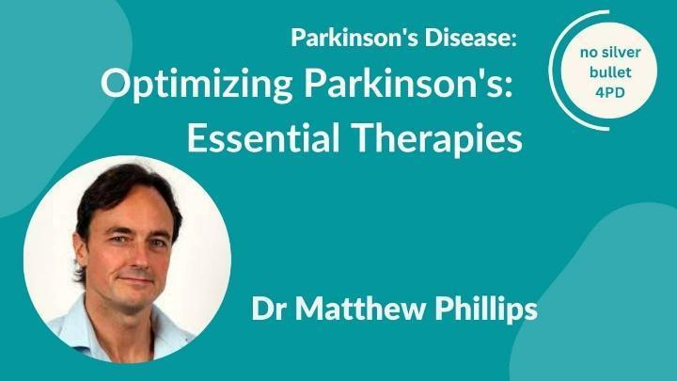
Matthew Phillips is a clinical and research neurologist at Waikato Hospital, Hamilton, New Zealand. His foremost interest is to explore the potential feasibility, safety, and efficacy of metabolic strategies, particularly fasting and ketogenic diets, in creating alternative metabolic states that may benefit people with various neurological disorders. His team conducted the world’s first randomised trials involving a ketogenic diet in people with Parkinson’s and Alzheimer’s disease. Access this talk at this link: https://www.youtube.com/watch?v=3uSKVmYNui8.
Editor adds: This talk provides one consultant’s comprehensive view of different aspects of Parkinson’s, causes due to mitochondrial damage and treatments. Definitely worth listening to but I found Dr Phillips’ rate of delivery too fast for my poor old Parkinson’s brain to keep up with it all. He covers virtually every aspect of the problem, mitohormesis, treatments, diet, spacing ones’ meals to maximise levodopa uptake, the value of fasting, how to improve sleep, ketogenic diet trials showing improved non-motor effects, stress etc. I tried to take notes, but my hand was shaking, and I can’t now read what I wrote down, so I had to listen to it again. The questions at the end were very helpful as he spoke slower in answering a specific point.
Please remember that the opinions he expresses about treatments, diet, etc, are his own opinions, Your consultant may have different views!
8. THE LATEST ON CELL REPLACEMENT THERAPIES FOR PARKINSON’S
A recording of this excellent Cure Parkinson’s online seminar is available at this link.
Editor: I advise watching all the separate recordings from this excellent meeting. which starts with a very clear overview talk by Dr Agnete Kirkeby from Lund University in Sweden. She summarises the whole field of cell replacement therapies. As the Chair of the session remarked, Dr Kirkeby gave a superb summary of the area suitable for lay and scientific audiences alike. Dr Kirkeby is giving the Edinburgh lecture described above.
The comments of the panel in the discussion session comparing DBS, stem cell treatments and gene modification techniques are all especially thought provoking, but all the cell replacement therapies are still many years away from being rolled out as a routine therapy for treating Parkinson’s.
9. ASK THE DOCTOR
A video from the Michael J Fox Foundation in which two neurologists, Drs Dean Sherzai and Dr Ayesha Sherzai, the brain doctors, talk about brain health with Dr Rachel Dolhun, principal medical advisor at the MJFF. They explore what steps to take to make a meaningful difference in brain health including exercise, sleep, diet and more, why consistency matters more than perfection and how to support loved ones. This video offers strategies for brain health that apply to everyone including those living with Parkinson’s.
Access this video from the Michael J Fox Foundation at this link.

PARKINSON’S RESEARCH NEWS
1. Monthly Research News from Parkinson’s UK
This latest roundup of research news from Parkinson’s UK contains some very readable articles, especially one about mitochondria and a new drug NRG5051 which is just entering trials. NRG5051 blocks pores which form in mitochondrial membranes in Parkinson’s so reducing their ability to produce the main form of energy a cell uses, namely ATP. NRG5051 prevents mitochondrial dysfunction via inhibition of the mitochondrial permeability transition pore (mPTP) through a novel protein target. In animal models Inhibition of mPTP in the brain prevents neuronal cell death and reduces neuroinflammation. NRG5051 has potential to treat Parkinson’s, and initial trials are just starting.
There is also an account of work on another brain cell type, astrocytes, which exist as interconnected networks in the brain supporting nerve cell function by supplying growth factors and removing waste products. However, when nerve cells are damaged or when toxic proteins such as α-synuclein accumulate, astrocytes become reactive and release damaging pro-inflammatory molecules which contribute to dopaminergic neuron death and disease progression. Editor: The charming photo of Dr Nataly Hastings holding a brain in this article reminds me of a not so charming scene in the 1979 sci-fi/horror film ‘Alien’.
ACCESS THIS LATEST EDITION OF PARKINSON’S UK’S RESEARCH NEWS here.
2. TESTING A SECOND WELLNESS BEECHBAND

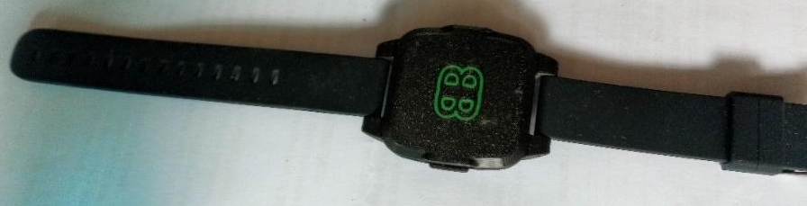
For anyone who hasn’t got or seen the BeechBand here is a photo of the prototype device I was given free to test from Parkinson’s UK. It weighed 40g including the strap, which isn’t too bad considering my simple Casio watch weighs 33g with the strap. The BeechBand is bulkier, however and extends over 1cm off my wrist and is approx. 4cm x 4.5cm square. It had a comfy plastic strap with a buckle. I found the on-off button hard to press to start the device.

Before I could test its effects on any Parkinson’s symptoms like tremor the device stopped pulsing when on my wrist though it worked on charge. On contacting the BeechBand team for a replacement I was told that my original free model was a prototype and that only a new model was available. This would cost £49.50 and has a sturdier casing to prevent the connections between the internal parts working loose as the device flexes. Presumably this is why my prototype model had failed. The new sturdier model comes with a 6-month warranty and 45-day return window. I listened to the September 8th NSB4PD interview with Carl Beech (above) and, though not very impressed by his rather indistinct account, I ordered the new model so I could continue my tests. Apologies but I forgot to weigh the new model.

Battery life: Battery life in the prototype model was about 3h 30min (n=3) and I found it was much the same in the replacement device at 3h 12min (n=4). These figures agree with the data sheet that came with the prototype which states that the battery has a life of 2-3 hours before it needs recharging for 45 minutes. This short battery life is a major criticism which the BeechBand team say they are working to improve.

Testing: I found the prototype device rather noisy and the strong pulsing every second quite intrusive. The newer model was much the same. The recommendation is to first try the BeechBand on the opposite wrist to the arm where tremor is more noticeable, the left wrist in my case. I ended up trying the device on the underside and top of both wrists. Doing up the buckle took some practice, made worse as tremor in my left hand increased as I got stressed trying to get the device fastened. In the webinar Carl Beech states that he wears his BeechBand for a couple of hours a day and he has discarded his Parkinson’s medication. In a more recent webinar, his advice is to wear the device ‘a lot’ or for 7 hours a day at least. I repeated these tests on my wrists a couple more times but found the pulsing intrusive and because I was getting annoyed, tremor increased. I admit I did not try the BeechBand for the 6 weeks recommended on the web site before making a decision about the device nor did I try it round an ankle as some people asked about in the webinar - I found it hard to bend low enough to fasten the buckle.

In a more recent webinar Carl Beech thought that the device might modify Parkinson’s symptoms by ‘placebo and comfort’ effects. BeechBand are organising a scientific team to investigate how the device could be working for some people and not others. There is no way of altering the strength and amplitude of the pulse as is possible with the Cue1 device. When asked about this the reply was that in their experience one strength at a fixed amplitude seems to suit all. This seems surprising for Parkinson’s where everyone's pattern of disease progression is different! I suspect that the mechanics needed to vary pulse strength and amplitude would make the device heavier and bulkier.

I wasn’t impressed by the webinars which were confusing and contradictory. I returned the replacement device on the money back offer. I asked my Parkinson’s nurse to check whether any other PwP on her lists were using the BeechBand and with what effect. So far she has found one man trying it and he thought that it did reduce his Parkinson’s symptoms somewhat though I have no details of how long he was wearing the device for.

Having tested some other mechanical devices (eg eyeguide, Cue 1) to no effect I must admit approached testing the BeechBand with some scepticism especially as in the webinar much of the supporting evidence is anecdotal and no results from a proper scientific trial have been reported though apparently suh trials are planned. Judging whether the device is having an effect on one’s Parkinson’s symptoms is, to my mind, totally subjective so very difficult to tell whether the device is having an effect. I am intrigued that Parkinson’s UK are supporting the BeechBand financially which suggests they have spotted something about the device which I have missed and that I should have continued testing for longer.

The BeechBand is not a cure- and it will not stop one’s Parkinson’s progressing but if some PwP find that it reduces their symptoms and makes daily living more tolerable does it matter how it works?

The link to the BeechBand site with success stories is here.

LATEST BEECHBAND NEWS: I now receive regular emails from the BeechBand team and have learned that on November 10th a new model of the BeechBand (the100-D) will be released and can be ordered that day. This 100-D version has an LED charging light and a strap without a buckle which will make it easier to put on. It also contains a new motor which is quieter. There is no mention that the battery life of 3 hours has been extended. This 100-D model costs £54.50 plus postage/packing. The current mode is still available at £44.50.

Editor: If you are thinking of trying the BeechBand I would wait until the 100-D version is available on November 10th. It is clear that the BeechBand team are listening to problems raised by users of earlier models so ultimately perhaps a version with a longer battery life will be developed to meet that criticism. If such a model becomes available I might be tempted to test it again.

Editor cautions: On the Instructions page that came with the prototype device it is stressed that if you have had DBS, you should seek medical advice before using the BeechBand! In one of the webinars, I heard it claimed that the BeechBand and DBS are compatible. Check this with your medical advisor!

PARKINSON’S TRIALS NEEDING VOLUNTEERS
Don’t forget that by volunteering for many of these opportunities you are consenting to your email being shared with the researcher(s) involved in the project.

1. SUPPORTING CONVERSATIONS ABOUT CARE PLANNING
Lis Grey, from the University of Bristol, is designing a research proposal which aims to support clinicians to have care planning conversations earlier and more often with people with Parkinson’s. Before she applies, she’d like to hear the views of people affected by Parkinson’s on her research plan and if it is an important area for her to focus on.

What/how: Join a group discussion
When: The 15th and 16th of October
Where: Online videocall – support about videocalling will be available if needed.

You will be offered payment for your time. You can read our guidance on payments attached to this email.

Who is needed: People with Parkinson’s, plus people who support PwP.

Discussions about future care are vital. They guide decisions if someone is no longer able to make choices for themselves. However, these conversations often don’t take place, or they start too late. If you want to get involved, please fill in the form at this link.

If you have any questions or if there are any adjustments we can make to help you get involved, please email Lis at e.b.grey@bristol.ac.uk . Remember to send a copy of your email to researchinvolvement@parkinsons.org.uk)

2. DOES EXERCISE BUILD RESILIENCE IN PEOPLE WITH PARKINSON’S?

A PhD student wants to understand how exercise affects the resilience of people with Parkinson’s. The student is keen to learn how exercise may help PwP feel stronger and how it can improve their quality of life. This research will also explore what type of exercise people with Parkinson’s prefer. This trial is based at the Medical School in Derby Royal Hospital so is very convenient for PwP in the Derby area.
Who is needed: 16 people with Parkinson’s who are over 40 years old, can walk 30m with or without a walking aid and can travel to Derby Medical School. Sorry but anyone with a diagnosis of dementia or another neurological conditions is ineligible.
What is involved:
- Travel to Derby Royal for two study visits, the first involving an hour’s screening for the study
- The second visit will last 3.5 hour including breaks and you will complete assessments of your strength, balance and flexibility,
- On this second visit you will take part in cycling or walking at a moderate pace for 40 minutes.
You will be paid £150 for travel expenses and for taking part in the study. Parking spaces will be provided for anyone coming by car and members of the research team will provide help with Turkish, Arabic, Portuguese and Mandarin if needed. A supporter may attend the study visits if necessary.
For more information read the participant information sheet.
To take part email Mehmet at: Mehmet.cagatay.yildirim@nottingham.ac.uk or sign up here.
3. ‘A PLACEBO-CONTROLLED CROSS-OVER TRIAL OF RHYTHMIC 10HZ MEDIAN NERVE STIMULATION FOR THE REDUCTION OF PARKINSON'S TREMOR.’

Who is needed: 60 volunteers with a diagnosis of Parkinson's and a resting tremor in one or both hands/arms.

Where: Department of Psychology, University of Nottingham.

How: The trial involves 3-4 visits to determine how an active stimulation compares to a placebo stimulation. You will be randomly allocated into the active or placebo groups but volunteers in the placebo group will be able to try the active stimulation at the end of the trial.

During the first visit researchers will deliver questionnaires to assess your symptoms, tremor and wellbeing. To assess your tremor, a short video will be taken of you and researchers will also give you an accelerometer device to take home for the duration of the trial. This measures your tremor frequency. At the second visit, you will repeat the questionnaires from the first visit and then receive one session of active or placebo stimulation. On your third visit, you will repeat the questionnaires given at the first and second visits. If you are in the placebo group, you will have the opportunity to try the active stimulation during this third visit and be invited back for an additional session. You will also be asked to perform a simple movement task once during your first and last visit and twice during visits where you receive stimulation. The task involves tapping on circles on a screen as fast as you can.

We will offer an inconvenience allowance of £10 per hour, and we will contribute up to £45 per visit to help you with travel expenses for your visit to the University of Nottingham.

For further information about this work please contact: mairi.houlgreave1@nottingham.ac.uk or caitlin.smith1@nottingham.ac.uk. There is no closing date for recruitment, but we will stop recruiting once we have 60 eligible participants.

Editor adds: Mairi says they still need more volunteers……!
4. EXPERIENCES OF PEOPLE WITH PARKINSON’S USING MENTAL HEALTH SERVICES.
This trial is open until April 2026. Learn more about what is required by using this link.

5.THE CAN-PDP TRIAL – IS CANABIDIOL AN EFFECTIVE TREATMENT FOR PARKINSON’S PYCHOSES?

About 60% of PwP experience hallucinations - seeing/hearing/feeling things that are not really there. Many also suffer delusions (ie. strange beliefs). Collectively these are known as Parkinson’s psychoses (PDP). The CANnabidiol for Parkinson’s Disease Psychosis trial is a clinical drug trial investigating whether cannabidiol (or CBD) is a safe and tolerable treatment for reducing these psychotic symptoms in PwP. This trial is still open for recruitment in multiple sites across England.

This study is important because the current treatment strategies for PDP are either not very effective, safe, or convenient for everyday use. So, we are looking at cannabidiol (or CBD) as a safer, more tolerable alternative treatment. More information can be obtained via this link.

5. UNDERSTANDING EMOTION MANAGEMENT AND WELL BEING.
Click here for more information.

CURE PARKINSON’S/PARKINSON’S UK JOINT ‘GET INVOLVED IN RESEARCH’ LEAFLET.
Cure Parkinson’s and Parkinson’s UK have put together a co-branded leaflet with a number of ongoing opportunities to get involved in research for people with Parkinson’s in the UK - click here to access the leaflet.

PARKINSON’S UK RESEARCH SUPPORT NETWORK. This site advertises other trials needing volunteers. So click on the Take Part Hub on the Parkinson’s UK website to find other research projects needing volunteers.
________________________________________________________________________
Newsletter comments, queries, corrections, arguments, and submissions to the Editor (Martin Rumsby) at: martin69747@gmail.com. If you have any top tips for coping with your Parkinson’s, special diets, exercise regimes, etc., that you would like to share with us in this Newsletter, email the editor.
Any mistakes in the details above are entirely the fault of the Editor!

Thanks: The Editor greatly appreciates help from Mia from the PEMRIG steering group with help in proofreading this newsletter and with shortening long links.

Parkinson's UK is registered at 50 Broadway London, City of London, SW1H 0DB, GB and is the operating name of the Parkinson's Disease Society of the United Kingdom. A registered charity in GB (258197), and in Scotland (SC037554).
Parkinson's UK accepts no liability for the content of this email or for the consequences of any actions taken on the basis of the information provided, unless that information is subsequently confirmed in writing. Any views or opinions presented in this email are solely those of the author and do not necessarily represent those of the charity.

