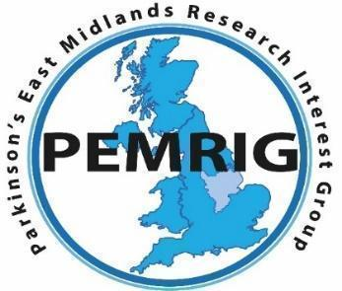


PEMRIG
PARKINSON’S EAST MIDLANDS RESEARCH INTEREST GROUP
A hopeful and happy New Year to all East Midlands’ people with Parkinson’s and those further afield, their families, health professionals and others reading this January 2026 edition of the PEMRIG newsletter. Please consult the PEMRIG website (https://pemrig.org.uk) for details of past laboratory visits, research seminars, Face 2 Face meetings and our recent lunch-time research talks.
PEMRIG is one of thirteen Parkinson’s UK affiliated ‘Research Interest Groups’ around the UK. The aim of the RIGs is to interest People with Parkinson’s (PwPs) in the exciting Parkinson’s research going on in the UK and all round the world. By following the research it is clear that good progress is being made to understand and beat Parkinson’s.
To be added to the mailing list for this monthly online newsletter or to express an interest in joining the PEMRIG steering committee, please contact Liz Nash, Research Support Network Lead and PEMRIG’s Acting Chair at Parkinson's UK at: lnash@parkinson’s.org.uk.
A. PEMRIG NEWS
1. Readers will be pleased to hear that online and in person donations to Parkinson’s UK in memory of John Turner, PEMRIG’s late Chairman, totalled £1,400. This great response will help fund more research.
2. HOW AND WHY DOES HAVING PARKINSON’S CHANGE THE CHEMISTRY OF OUR SKIN OILS?
MONDAY, FEBRUARY 9th, 2026, 2.00 to 3.30pm
Join PEMRIG on a virtual visit to Professor Perdita Barran’s laboratory in Manchester where research is in progress to characterise the chemical changes that occur in the sebum (skin oils) of PwP, what causes the changes and how such changes are associated with seborrheic dermatitis which occurs commonly in PwP.
Joy Milne, who is hyperosmic, amazed the Parkinson’s community when she first reported years ago that she could detect PwP by their altered odour. Professor Barran’s team now use sophisticated chromatography and mass spectrometry methods to identify the chemical changes occurring in sebum.
A rapid, non-invasive test for Parkinson’s based on the changes occurring in sebum is being developed in a spin-off company Sebomix. Such a test may offer a rapid diagnosis of Parkinson’s before the onset of symptoms. Professor Barran also co-authored the recent report that certain dog breeds can be trained to detect PwP by the changed composition of their sebum. There should be plenty to discuss.
To join this laboratory visit, you need to register at this link.
B. UPCOMING AND RECENT TALKS ABOUT PARKINSON’S

1.THE BEST DIETS FOR PD: MEDITERRANEAN, MIND, AND ANTI-INFLAMMATORY PATTERNS
WHEN: Thursday, 29 January, 19:00 to 21:30 (UK Time)
WHERE: Online
Apply for tickets to hear this talk at this link.

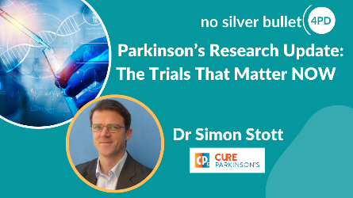
2. PARKINSON’S RESEARCH UPDATE - THE TRIALS THAT MATTER NOW!
When: January 12th at 7.30 – 9.00pm (London time)
Where: Online
This is a good opportunity to get a direct update of the most important trials testing new Parkinson’s drugs. Dr Simon Stott, Head of Research at Cure Parkinson’s, has over 20 years of experience across academia and biotech and is renowned for explaining the complex science of Parkinson’s in plain English. In this talk, Simon will review which breakthroughs moved the needle in 2025 and which trials should be watched in 2026. The talk will be followed by an interactive Q & A session.
To register for this talk click here.
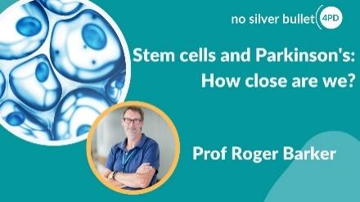
3. STEM CELLS AND PARKINSON’S – HOW CLOSE ARE WE?
Professor Roger Barker from the University of Cambridge, and one of the top researchers in this area, reviewed the latest global developments in stem cell research for Parkinson’s. He explored where research truly stands today and how close we are to seeing real therapeutic benefits.
You will find Roger Barker’s talk here.
4. TURNING TRIALS INTO THERAPIES.
If you missed Dr Kevin McFarthing and Dr Simon Stott talking at PEMRIG’s lunchtime seminar, you can find the recording online here.

C. PARKINSON’S RESEARCH NEWS – a statement of hope!

1, Editor writes: I got a bit depressed by hearing Kevin McFarthing reveal in his PEMRIG lunchtime talk last November, how few of the drugs in Parkinson’s trials are in the critical Phase 3 testing needed for advancement to the clinic. I wondered if assembling the HOPE list each year made Kevin depressed at the rate of progress relative to the amount of money spent and the number of years research into Parkinson’s has been going on. So I asked him about this. His reply was unexpected and improved my mood in time for Christmas. His reply is reproduced below with his permission.
‘Hi Martin. Perhaps surprisingly, the Hope List makes me optimistic. The massive effort and investment going into PD is mind-blowing. The fact that most of it is in relatively early stage development is disappointing, of course, but I would rather have that investment in Parkinson’s than in other diseases. There have also been new additions to the phase 3 roster in the last year or so - prasinezumab, ambroxol, terazosin, telmisartran, with UDCA coming down the tracks for next year. Even though there are only 10 million of us, that is a relatively large population for a drug company these days, especially when you factor in the likely need to take disease-modifying drugs every day for the rest of our lives. That’s why behemoths like Roche, Biogen and Abbvier are all investing big into Parkinson’s. In addition, there has been a lot of investment from philanthropists and charities, particularly with EJS ACT-PD. So, while I find the gap in phase 3 DMT trials very frustrating, I remain encouraged and hopeful’. Best regards, Kevin.
2. For more ‘hope’ read the top ten Parkinson’s news stories of 2025 as published in the 30/12/2025 edition of Parkinson’s News today at this link.

D. PARKINSON’S TRIALS NEEDING VOLUNTEERS
1. Edmond J Safra Accelerating Clinical Trials in Parkinson’s (EJS ACT-PD), the world’s largest clinical trial for Parkinson’s, is now recruiting in the London and Newcastle areas. By mid-2026 40 other sites across the UK should be open for recruiting. Cure Parkinson’s and Parkinson’s UK are both involved in funding this new multi arm multistage (MAMS) platform in which several drugs are tested against one placebo compound and where a drug that is observed to be ineffective can be withdrawn and replaced by a new drug.

Overall this trial will need 1600 volunteers and is costing something like £29 million. The Parkinson’s UK link below sets out the requirements and includes a form to register your interest even though most local centres haven’t started recruiting yet. This is a great chance to get involved in a new big trial. The first two repurposed drugs being tested are terazosin and telmisartan both being in the final Phase 3 stage of testing. A third compound, ursodeoxycholic acid will be added in 2026.

Click on this link to register your interest.

Details of trials supported by Parkinson’s UK and Cure Parkinson’s are given in the links below for you to consult if interested. Don’t forget that by volunteering you may be consenting to your email being shared with the researcher(s) involved in the project.

CURE PARKINSON’S/PARKINSON’S UK JOINT ‘GET INVOLVED IN RESEARCH’ LEAFLET.
Cure Parkinson’s and Parkinson’s UK have put together a co-branded leaflet with a number of ongoing opportunities to get involved in research for people with Parkinson’s in the UK - click here to access the leaflet.

PARKINSON’S UK RESEARCH SUPPORT NETWORK. This site advertises other trials needing volunteers. So click on the Take Part Hub on the Parkinson’s UK website to find other research projects needing volunteers.
________________________________________________________________________
Newsletter comments, queries, corrections, arguments, and submissions to the Editor (Martin Rumsby) at: martin69747@gmail.com. If you have any top tips for coping with your Parkinson’s, special diets, exercise regimes, etc., that you would like to share with us in this Newsletter, email the editor.

Any mistakes in the details above are entirely the fault of the Editor!
Thanks: The Editor greatly appreciates help from Mia from the PEMRIG steering group with help in proofreading this newsletter and with shortening long links.

Parkinson's UK is registered at 50 Broadway London, City of London, SW1H 0DB, GB and is the operating name of the Parkinson's Disease Society of the United Kingdom. A registered charity in GB (258197), and in Scotland (SC037554).
Parkinson's UK accepts no liability for the content of this email or for the consequences of any actions taken on the basis of the information provided, unless that information is subsequently confirmed in writing. Any views or opinions presented in this email are solely those of the author and do not necessarily represent those of the charity.

