


PEMRIG
PARKINSON’S EAST MIDLANDS RESEARCH INTEREST GROUP
NEWSLETTER MARCH 2026

Welcome to all East Midlands’ people with Parkinson’s (PwP) and those further afield, your carers and families, health professionals and others reading this latest edition of the PEMRIG newsletter. Please consult the PEMRIG website (https://pemrig.org.uk) for details of recent laboratory visits, research seminars, Face 2 Face meetings and our recent lunch-time research talks.

PEMRIG is one of thirteen Parkinson’s UK affiliated ‘Research Interest Groups’ around the UK. Our aim is to interest PwP in the exciting Parkinson’s research going on all round the world and by doing so, raise the hopes of PwP that steady progress is being made to understand and beat the condition.

To be added to the mailing list for this monthly online newsletter - please contact Liz Nash, Research Support Network Lead at Parkinson’s UK and PEMRIG’s Acting Chair, at: lnash@parkinson’s.org.uk.
____________________________________________________________________________________________________
URGENT- The TOP HAT trial of a licensed drug as a Parkinson's Hallucination Treatment needs volunteers - join via KING’S MILL Hospital near Mansfield. Full details in Section 3. Please help if you are eligible!
PEMRIG NEWS
If you missed PEMRIG’s virtual lab visit on February 9th to hear about ‘HOW PARKINSON’S CHANGES THE CHEMISTRY OF OUR SECRETED SKIN OILS’, you will find a recording at this link.
UPCOMING AND RECENT TALKS ABOUT PARKINSON’S
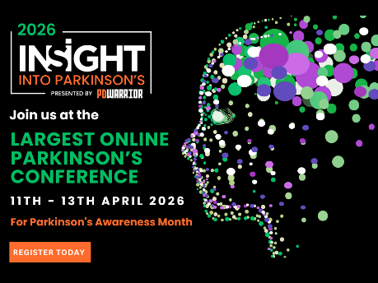
1.’INSIGHT INTO PARKINSON’S 2026’
Leading experts from the Parkinson's community will discuss the latest research, treatments and strategies to live well with Parkinson's. As usual, the last day is for health care professionals.
When: April 11th – 13th
Use this link to find the list of speakers and to register.

2. ‘MAKE THE MOMENT COUNT: PROMOTING RESEARCH ON WORLD PARKINSON’S DAY 2026’
When: March 18th, 5pm (London) by zoom
You are being invited to join the Parkinson’s UK’s Research Team to come together and learn how you can ‘make the moment count’ on World Parkinson’s Day by encouraging everyone to get involved in research.
We will let you know: 1, How to stay up to date with research news and opportunities, 2, How you can order our free research leaflets, magazine and other resources, and 3, tips on how you can use these resources to encourage others in the Parkinson’s community to take an interest and get involved. We will also tell you more about World Parkinson’s Day events around the UK that you can join.
This webinar is for everyone – PwP, their carers, health care professionals, researchers, and anyone who wants to help raise awareness about Parkinson’s across the UK.
Register to attend, at: https://parkinsons-org-uk.zoom.us/meeting/register/tEPiGd1CRhCoNBQ0D5N-ww
If you have any questions about this event, please contact Alice Keogh at Parkinson’s UK on akeogh@parkinsons.org.uk or 020 7963 3610.
3. THE BRAIN’S BACKUP PLAN: THE POWER OF NEUROPLASTICITY IN PARKINSON’S. A recording of this talk by Dr Helmich is available at this link.
Editor: I found this talk fascinating but quite hard going. An easier to read summary of Dr Helmich’s talk is included in Section 2 on Parkinson’s research.
4. FOCUS ON NUTRITION: A COMPEHENSIVE LOOK FROM DIETS TO DAILY CARE!
In an exciting development, the NSB4PD team are collaborating with PD Buddy over the next year to deliver a twelve-part series of webinars under the heading above. All the webinars will be led by DrTanya Denne, a Naturopathic Doctor and researcher, who will be joined by other experts to discuss the vital role of nutrition in neuroprotection.
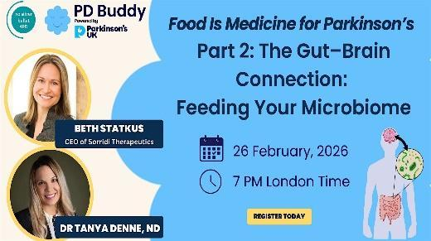
The series will include discussion of special diets, the gut-brain axis, eating for protection, anti-oxidants, vitamins and bone health, how dietary proteins interfere with L-DOPA uptake, whether red wine is protective or problematic, ultra processed foods, the keto diet and intermediate fasting. By December you should have a personalised road map for enjoying your meals having gathered practical tips on mindful eating and safe swallowing.
This series isn’t going to take the pleasure out of eating, it’s all about helping PwP live with the condition and enjoying the right food at the same time.
When: February 26th, 7.00pm (London Time)

Register to attend here.
This talk about the gut-brain connection will be over by the time this newsletter gets to you. A recording and any summary will appear in the April edition.
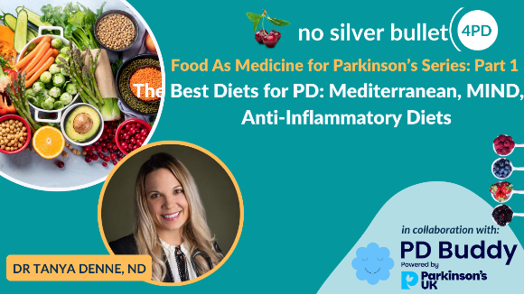
The first webinar in the series had the title ‘’THE BEST DIETS FOR PARKINSON’S: MEDITERRANEAN, MIND, AND ANTI-INFLAMMATORY PATTERNS’. If you missed this first webinar you can listen to it again here.
The NSB4PD and PD Buddy groups have produced a brilliant summary of webinar 1 which can be accessed by clicking this link or entering it in your in your browser: https://preview.mailerlite.io/emails/webview/543984/178116704040126114.

5. A ‘Catch up on young onset Parkinson’s’ webinar
You can now catch up with a recent webinar on young onset Parkinson’s. Professor Tilo Kunath from Edinburgh University was joined by an expert panel t o discuss what YOPD is
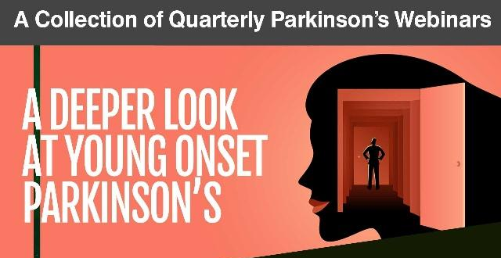
and how it presents, as well as the potential genetic links. The panel also explored research opportunities for people with YOPD.
Watch this webinar at this link.

PARKINSON’S RESEARCH NEWS
Here is a summary of what Dr Helmich was talking about in his recent NSB4PD talk.
The Brain’s Backup Plan: How Resiliency and Compensation Define the Parkinson’s Journey
For many years, the standard narrative of Parkinson’s has been a straight line: dopamine cells in the brain die, dopamine levels drop, and symptoms appear. However, as Dr. Rick Helmich, a movement disorders neurologist and researcher, shared in a recent No Silver Bullet 4 PD webinar, the reality is far more hopeful and complex. It turns out the brain is not a passive victim of cell loss; it is an active fighter with a sophisticated "backup plan."
In this article, we explore the science of brain compensation—why symptoms often stay hidden for years, what happens when the brain "bridges the gap," and how we can use lifestyle to protect these vital secondary pathways.
The Mystery of the Missing Symptoms
One of the most surprising facts in neurology is that by the time a person experiences their first tremor or stiffness, they have already lost more than 50% of the dopamine-producing cells in a region called the substantia nigra.
If dopamine were the only factor, we would expect symptoms to appear much earlier. Dr. Helmich points to fascinating animal studies as evidence of the brain's resilience. When a toxin that kills dopamine cells is injected all at once, the subject immediately shows symptoms. However, if the exact same amount of toxin is given slowly over several weeks, the brain adapts so effectively that the subject often shows no symptoms at all.
This tells us that because Parkinson’s in humans progresses slowly over many years, the brain has time to rewire itself. This process is known as brain compensation.
Where is the "Backup System" Located?
Using advanced fMRI scans, researchers can now see exactly which parts of the brain are working overtime to compensate for the loss of dopamine. While deep areas like the basal ganglia (the primary movement hub) show reduced activity, other areas on the outer surface of the brain—the cortex—actually show increased activity in people with the condition compared to healthy individuals.
Specifically, two areas take the lead:
The Parietal Cortex: Responsible for processing sensory information and attention.
The Premotor Cortex: Involved in planning and executing movements.
These areas work harder to "bypass" the malfunctioning deep brain structures. This is why many people find that visual cues—such as lines painted on a floor or the rhythm of a song—can suddenly "unlock" their movement. You are essentially using your cortex (the backup system) to plan a movement that the deep brain (the primary system) can no longer handle automatically.
Why Do Symptoms Eventually Progress?
If the brain is so good at compensating, why do symptoms eventually increase? Dr. Helmich’s research suggests a radical new perspective: progression may not be caused solely by the loss of more dopamine, but by the collapse of the compensation system.
In a study of 350 people, Dr. Helmich found that those who progressed the fastest over a two-year period were those whose cortical activity (the backup plan) began to decline. Conversely, those who progressed slowly were the ones whose brains successfully maintained that extra activity in the parietal and premotor areas.
Protecting Your Backup Plan: The Role of Lifestyle
If the goal is to keep the "backup plan" running for as long as possible, how do we protect these compensatory pathways? Dr. Helmich highlights that these hard-working brain areas require immense amounts of energy. This energy is produced by mitochondria, the tiny power plants inside our cells.
To "serve and protect" these energy-hungry brain regions, we need a holistic approach:
Vigorous Exercise: Physical activity is one of the most effective ways to boost mitochondrial health and promote neuroplasticity (the brain's ability to rewire).
Learning New Skills: Challenges like boxing, dancing, or learning a new language force the cortex to engage. When we learn something new, we stimulate the outer layers of the brain, reinforcing the backup pathways.
Stress Management: High stress and anxiety can "overburden" the cortex. When the brain is overwhelmed by stress, it loses the focus required to maintain compensatory movement. Techniques like mindfulness help "free up" the brain to focus on movement.
The Mediterranean Diet: Emerging evidence suggests this diet reduces low-grade inflammation and supports the gut-brain axis, ensuring the brain has the nutrients and environment it needs to stay resilient.
Is Levodopa Still Important?
A common worry is whether taking medication like Levodopa for a long time might damage this natural compensation. Dr. Helmich is clear: No. In fact, medication and compensation work together.
Dopamine helps the deep parts of the brain function better, which in turn reduces the "load" on the cortex. This synergy allows you to move more freely, which then allows you to exercise more, further strengthening your brain's backup plan.
Summary: The Resilient Brain
The takeaway from Dr. Helmich’s research is one of empowerment. While we cannot yet stop the loss of dopamine cells, we have significant influence over the resilience of our backup system. By treating lifestyle as "medicine"—through exercise, nutrition, and stress reduction—we provide our brains with the energy needed to bridge the gap and stay better for longer.
LOCAL PARKINSON’s RESEARCH TRIALS NEEDING MORE VOLUNTEERS
1. A PLACEBO-CONTROLLED CROSS-OVER TRIAL OF RHYTHMIC 10HZ MEDIAN NERVE STIMULATION FOR THE REDUCTION OF PARKINSON'S TREMOR.’
Who is needed: 60 volunteers with a diagnosis of Parkinson's and a resting tremor in one or both hands/arms. Where: Department of Psychology, University of Nottingham. How: The trial involves 3 - 4 visits to determine how an active stimulation compares to a placebo stimulation. You will be randomly allocated into the active or placebo groups but volunteers in the placebo group will be able to try the active stimulation at the end of the trial. During the first visit researchers will deliver questionnaires to assess your symptoms, tremor and wellbeing. To assess your tremor, a short video will be taken of you and researchers will also give you an accelerometer device to take home for the duration of the trial. This measures your tremor frequency. At the second visit, you will repeat the questionnaires from the first visit and then receive one session of active or placebo stimulation. On your third visit, you will repeat the questionnaires given at the first and second visits. If you are in the placebo group, you will have the opportunity to try the active stimulation during this third visit and be invited back for an additional session. You will also be asked to perform a simple movement task once during your first and last visit and twice during visits where you receive stimulation. The task involves tapping on circles on a screen as fast as you can. We will offer an inconvenience allowance of £10 per hour, and we will contribute up to £45 per visit to help you with travel expenses for your visit to the University of Nottingham. For further information about this work please contact: Mairi.Houlgreave1@nottingham.ac.ukor caitlin.smith1@nottingham.ac.uk.
Editor: There is no closing date for recruitment, but more participants are still needed to reach the necessary total of 60.

2. TOP HAT - TRIAL OF A LICENSED DRUG AS A PARKINSON'S HALLUCINATION TREATMENT
Research teams across the UK are investigating if ondansetron has a meaningful treatment effect on Parkinson's and Lewy Body Dementia hallucinations. As this is an already licensed low-cost drug, if the research shows significant outcomes, ondansetron could be available for people with Parkinson's who experience hallucinations within the next few years.
Who is needed: 306 people diagnosed with Parkinson's or Lewy Body Dementia (LBD) who:
- experience visual hallucinations, see things that aren’t there, at least once every week.
- are not taking apomorphine or any anti-psychotic medication.
- and have been taking a stable dose of Parkinson's or LBD medication for 28 days before starting the research.
Where; At Sherwood Forest Hospitals NHS Foundation Trust, Kings Mill Hospital, Sutton In Ashfield, NG17 4JL, near Mansfield. (Plus a number of other sites around the UK)

What's involved? If you are eligible to take part, you will either receive ondansetron or dummy medication tablets for 12 weeks, which will be shipped to you via a courier. The research team will maintain regular contact throughout to take assessments and let you know how much medication to take. This contact will be through telephone, video call, and face-to-face.
3 face-to-face visits are required and, for some research sites, home visits may be an option.
For more information: contact the TOP HAT team at o.zubko@ucl.ac.uk or call 02031089073 and leave a voicemail message. More information is also available on the Parkinson's UK website: here.

Maria and Desmond's experience of taking part in the TOP HAT trial
“I’d really encourage anyone thinking about it to take part. It was so easy, just one more pill. And the research visits are just the same as the routine appointments. It was like having extra consultations, we felt like VIPs!” - Maria & Desmond. Read more about Maria and Desmond’s experience in the trial online here here.

Details of trials supported by Parkinson’s UK and Cure Parkinson’s are given in the links below for you to consult if interested. Don’t forget that by volunteering you may be consenting to your email being shared with the researcher(s) involved in the project.

CURE PARKINSON’S/PARKINSON’S UK JOINT ‘GET INVOLVED IN RESEARCH’ LEAFLET.
Cure Parkinson’s and Parkinson’s UK have put together a co-branded leaflet with a number of ongoing opportunities to get involved in research for people with Parkinson’s in the UK - click here to access the leaflet.

PARKINSON’S UK RESEARCH SUPPORT NETWORK. This site advertises other trials needing volunteers. So click on the Take Part Hub on the Parkinson’s UK website to find other research projects needing volunteers.
________________________________________________________________________
Newsletter comments, queries, corrections, arguments, and submissions to the Editor (Martin Rumsby) at: martin69747@gmail.com. If you have any top tips for coping with your Parkinson’s, special diets, exercise regimes, etc., that you would like to share with us in this Newsletter, email the editor.

Any mistakes in the details above are entirely the fault of the Editor!
Thanks: The Editor greatly appreciates help from Mia from the PEMRIG steering group with help in proofreading this newsletter and with shortening long links.
Parkinson's UK is registered at 50 Broadway London, City of London, SW1H 0DB, GB and is the operating name of the Parkinson's Disease Society of the United Kingdom. A registered charity in GB (258197), and in Scotland (SC037554).
Parkinson's UK accepts no liability for the content of this email or for the consequences of any actions taken on the basis of the information provided, unless that information is subsequently confirmed in writing. Any views or opinions presented in this email are solely those of the author and do not necessarily represent those of the charity.

