


PEMRIG
PARKINSON’S EAST MIDLANDS RESEARCH INTEREST GROUP
NEWSLETTER MAY 2026

Welcome to all East Midlands’ people with Parkinson’s (PwP) and all those further afield, your carers and families, health professionals and others reading this latest edition of the PEMRIG newsletter. Please consult the PEMRIG website (https://pemrig.org.uk) for details of recent laboratory visits, research seminars, Face 2 Face meetings and our recent lunch-time research talks. To be added to the mailing list for this monthly online newsletter, please contact Liz Nash, Research Support Network Lead at Parkinson’s UK and PEMRIG’s Acting Chair, at: lnash@parkinson’s.org.uk.

PEMRIG is one of thirteen Parkinson’s UK affiliated ‘Research Interest Groups’ around the UK. Our aim is to interest PwP in the exciting Parkinson’s research going on all round the world and in doing so, raise our hopes that steady progress is being made to understand and treat the condition.

STOP PRESS!
1. Dr Rob Skelly, Consultant Physician, Royal Derby Hospital is running several trials which need volunteers. Can you help? The trials are listed in section 3 of this Newsletter with links to sign up and/or express an interest.
2. See Section 2 - RESEARCH for exciting news about the launch of PARKINSON’S INSIGHTS, a brand-new collaborative platform created by the PD Buddy and NoSilverBullet4PD teams to move beyond the search for a "silver bullet" and empower you with the latest research and practical tools. This new website brings everything together in one place to help you stay informed and proactive about what is going on in Parkinson’s.
3. A half-day meeting on ‘ADVANCED PARKINSON’S’ is being planned by Parkinson’s UK from 1.00pm on JUNE 23rd at the Wilmot Community Centre, 16 Wilmot Street, Heanor DE75 7EF. More details in the next newsletter.
PEMRIG NEWS
1, If you missed PEMRIG’s recent virtual lab visit to hear about ‘HOW PARKINSON’S CHANGES THE CHEMISTRY OF OUR SECRETED SKIN OILS’, you will find a recording at this link.
2. Make a note of THURSDAY, SEPTEMBER 10th 2026. PEMRIG is helping Parkinson’s UK organise a Face 2 Face Research Day. More information in future newsletters.
3. Report on the Derby Parkinson’s Awareness Day, March 15th 2026 from Keith Venables.
The Parkinson's Team in Derby City have been deemed a Centre of Excellence and, after a recent research day which I attended at the Florence Nightingale Hospital on behalf of PEMRIG, I can see why! The day was a mixture of clearly presented research by Dr Alex Zirra (from the Royal London Hospital), a generous overview of Parkinson’s by Dr Rob Skelly and fun workshops on exercise, sleep, etc. I learned much more about my own condition in this one day than at any time since my diagnosis.
4. Report on the Mansfield Parkinson's Support Group’s ‘Advanced Parkinson’s Awareness Day’, April 9th, 2026 – from the Editor.
This event was held from 10.30am -3.30pm in ground floor rooms at the Holiday Inn close to Junction 28 for easy access by car. There was good parking and a convenient disabled toilet on the ground floor. The venue was very well chosen. I attended on behalf of PEMRIG as well as wanting to hear about living with ‘Advanced Parkinson’s’. PEMRIG had a table for fliers, etc. in a marketplace area adjacent to the conference room, shared with Parkinson’s UK, Nottinghamshire Hospice, Respectful Care and Carers Hub service.
The meeting, was attended by over 50 PwP, carers, friends, etc. The atmosphere was relaxed and informal throughout. The PEMRIG stand was kept busy at each break and by the start of the afternoon session there were 16 new signatures for the PEMRIG newsletter.
Talks from Chantel Witts and Lynette Robinson from the Neurological Outpatients Team at Mansfield Community Hospital got the audience exercising and answering a quiz about Parkinson’s. They were followed by Parkinson’s Consultant Dr Silva who emphasised the need to eat fibre to avoid constipation, to take plenty of water with one’s medication and to allow at least 45-60 minutes either side of a meal so that amino acids from digested proteins in the food don’t interfere with medication absorption. He and Samantha Haynes, a Parkinson’s nurse, answered lots of questions which were related to general aspects of living with Parkinson’s, not advanced aspects. A film featuring the experiences of some people with Parkinson's was shown. The morning programme repeated itself after a free hot lunch. There were few new attendees after lunch so I left at that point with brain drain after talking to so many people. I was glad to have attended flying the PEMRIG flag but, sadly, I didn’t learn anything helpful about ‘Advanced Parkinson’s’.
1. FORTHCOMING AND RECENT PAST TALKS ABOUT PARKINSON’S
a. FOOD AS MEDICINE FOR PARKINSON’S-PART 6:’Advanced nutraceuticals for brain health and mitochondrial support’
When: Thursday, 4 June 2026 from 19:00 to 20:00 (UK Time)

The sixth instalment of the Food as Medicine series Drt Tanya Denne, a distinguished Naturopathic Doctor, researcher, a leading advocate for "Personalised Medicine," a philosophy that treats the whole person rather than just a set of symptoms, moves beyond the kitchen to the cutting-edge of clinical supplementation. This session provides an objective look at how specific compounds can support mitochondrial function and protect the brain at a cellular level. We move past the marketing hype to examine what the latest research actually says about the supplements currently making waves in the community.
Mitochondria are the powerhouses of our cells, and supporting their efficiency is a primary focus for neuroprotection. We will explore the role of NAD+ precursors and the emerging interest in low-dose lithium as potential tools for maintaining cellular energy. The discussion continues with N-Acetylcysteine, a powerful antioxidant that shows promise in supporting brain connectivity, alongside popular natural options like Lion’s Mane for maintaining cognitive clarity.
The session will also address the broader landscape of supplements, from the role of Green Tea in managing protein health to an evidence-based review of CBD for those seeking better sleep and lower anxiety. By merging rigorous scientific data with real-world clinical observations, we aim to provide a clear roadmap through the complex world of nutraceuticals, helping you identify which options offer the most genuine potential for long-term health.
Register using this link: https://clicks.eventbrite.com/f/open-in-app/v2n6S5QRSobRDD8hjBXfbA~~/AAQxARA~/YaPOTW_lW9nT8oEamZRWSYciUq3KniryOoEY35151SEh76ZrK-lMaYfxt6B8U_qwH5ka1zO1cPwc95pb5JY13-RPqcpnWC0fokKON8UlbpbIPSbeQ4OtiUkJ5j61JLzUMzeuSg4k5VIMeU1bwqkx5McKz8yQDp6tWnfd1pUycrsGy_a2UijW237ezO-Ghh_88l5btArwl1VQowrEdijFCzye-y_sF9yZwZHdYMxUJ0BrAzIbtUOPHxS7ebCH2dT_3_XudRBPS2Qn-pu-HJr3rYBHogrWrdkr7AxYOZMMSoMhqIzKohA53i8fwfYLR2IxOwcw3JBOQgSyB16v4xd7upjDwRZv-tJsuamsOrTzXlaGPak-QP7_X51fHOMEg7uZ8LdrVo_kv4d56SfRpSeLIXwmtDU4v7SR2TbpniCdfX-bWRKLbug2XeopN1zVp41A

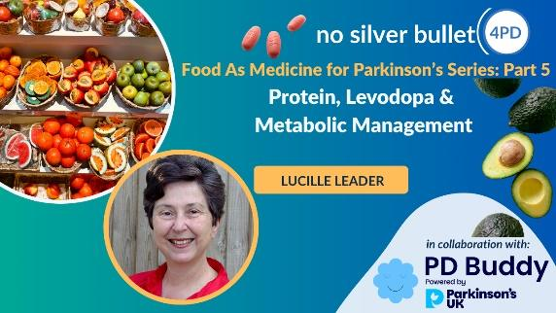
b. May 21st at 7.00pm (London time, GMT+1)
In the fifth part of the "Food is Medicine" series, the focus shifts to one of the most critical daily challenges for people with Parkinson’s: the relationship between dietary protein and medication effectiveness. This session is designed to be the perfect next step for those who have mastered the basics and are ready for an advanced, highly specific look at metabolic management.
Protein is essential not only for anabolic health but for the production of dopamine itself. But for those taking Levodopa, protein can be a double-edged sword. This is because specific amino acids in proteins use the same transport carrier as your L-dopa medication, so the timing of taking specific protein food in relation to L-dopa, needs to be precise. This webinar provides a specific and practical roadmap for timing protein intake relative to the time of taking L-dopa. The results will demonstrate how specialised individualised monitoring of drug response can manage the dreaded “off” periods and enable best efficacy of L-dopa. The presentation will also highlight the different metabolic processes that need to be supported in Parkinson’s Disease as well as Multidisciplinary Management. Lucille Leader is a renowned figure in the field of Nutritional Therapy specifically tailored for Parkinson’s Disease. Based in London, she is a Nutrition Director of the Parkinson’s Disease Integrated Nutrition Clinic. Register for this talk at this link.
c. May 7th at 7.30pm (London time, GMT+1)
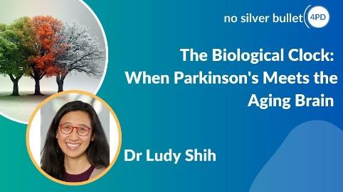
While we often discuss Parkinson’s in isolation, Dr Shih’s research explores the profound intersection between the condition and the natural process of brain ageing. In this session, she will explore the ways in which cellular and molecular mechanisms of Parkinson’s disease models are similar to, and different from, currently understood mechanisms of brain aging. Understanding these parallels is essential for developing a more comprehensive approach to long-term care. She will also explore how non-neurologic physiologic systems undergo aging and how this can impact people living with Parkinson’s disease.
This talk should provide you with 1, a deeper understanding of how cellular models of Parkinson’s compare with the standard processes of brain ageing, 2, an appreciation of how ageing affects the body beyond just the nervous system and what that means for people with Parkinson’s, and 3, how insights from large-scale, multi-generational studies are helping researchers identify the long term drivers of brain health. If you miss this talk, a catch-up link to a recording will be provided in the June newsletter.
Register for this talk at this link. If you have trouble connecting on the day use this direct link to join.

d. Food is Medicine for Parkinson's, Part 4: Anti-Inflammatory Power, Omega-Antioxidants & Supporting Brain Health.
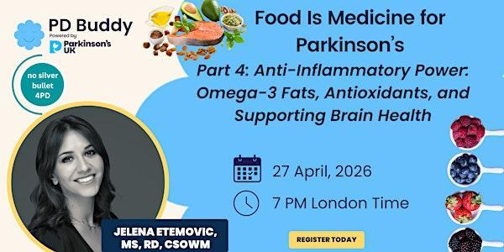
This was Part 4 of the ‘Food is Medicine for Parkinson's’ programme. Inflammation and oxidative stress are believed to play a role in Parkinson’s disease. Learn how targeted nutrition strategies, antioxidants, and omega-3 fatty acids may support overall brain health in Parkinson’s. This session offers a deep dive into the specific foods and compounds that help fight back against oxidative stress and support long-term brain health. The speaker explores the protective power of antioxidants, such as the flavonoids and polyphenols found in berries and green tea, and discusses the essential role of Omega-3 healthy fats from fish, nuts, and seeds. You will learn which foods provide the most robust protection for dopamine-producing neurons and how to integrate these evidence-based choices into your daily life.
Jelena Etemovic, MS, RDN, is a Registered Dietitian Nutritionist specialising in nutrition therapy for Parkinson‘s. She has published extensive research on the role of antioxidants and Omega-3 fatty acids in the progression of the condition. With a Master’s degree in Nutritional Science and a background in medical nutrition therapy, she focuses on solving the real-world challenges that many people face. Her expertise extends to managing digestive concerns and gut health, addressing fatigue and energy levels, supporting cognitive function, and improving sleep disturbances.
Jelena has produced a free Parkinson’s Brain Health Nutrition Guide filled with practical food lists, simple tips, and easy ways to get started. Access this guide at: https://jelena-etemovic-dietitian.kit.com/1b8038925f.
A recording can be found here.
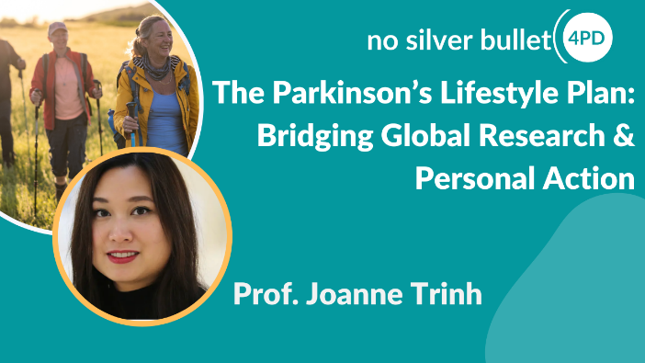
e. This webinar was first delivered on April 22nd. While we often discuss exercise or diet in isolation, Dr Trinh’s research highlights a powerful synergistic effect. A combined approach of targeted exercise, nutrition, stress management is significantly more effective than the sum of its parts. By addressing these factors together, we can create a "neuroprotective" environment that reduces inflammation and supports mitochondrial function.
You should listen to the recording to understand about
Slowing Progression: Understand how lifestyle modifications can help slow the progression of Parkinson’s.
The Power of Genetics: Dr Trinh will bridge the gap between genetic research and daily reality, explaining what your genetic profile actually means for your personal lifestyle plan.
Delaying Onset & Progression: Gain insights from her recent Lancet research on how lifestyle choices can influence the age of onset and, crucially for our community, the long-term trajectory of the disease.
You can catch this talk again at the new Parkinson’s Insights platform - see section 2, Research.
f. CURE PARKINSON'S SPRING RESEARCH UPDATE MEETING 2026. This meeting focused on inflammation and Parkinson’s, an area of growing interest as we begin to better understand the role inflammation plays in driving Parkinson’s progression. You will hear presentations from two researchers funded by Cure Parkinson’s. Here is a link to a recording of the two talks.
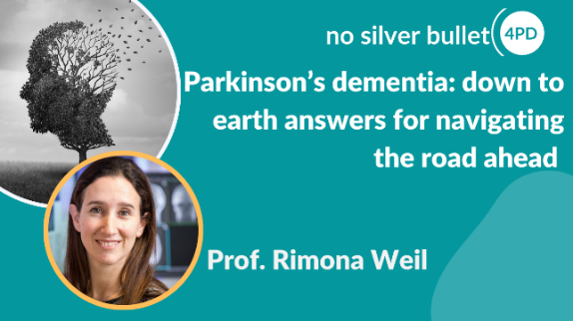
g. PARKINSON’S DEMENTIA: SOME DOWN-TO-EARTH ANSWERS
While we often focus on the motor symptoms of Parkinson’s, there is an elephant in the room that is much harder to discuss: cognitive change. Statistics show that people living with Parkinson’s face a significantly higher risk of developing dementia. Although it is not the most pleasant topic, it is an essential one to understand. Facing these facts head-on is the only way to ensure we are prepared for the road ahead.
Professor Rimona Weil from UCL is a leading expert in the field, renowned not only for her clinical excellence but for her ability to provide "down-to-earth" answers to the most difficult questions. This is a talk you truly cannot afford to miss. Empowering yourself with knowledge today is the best way to maintain control over your future.
Use this link to access a recording.

2. PARKINSON’S RESEARCH NEWS

a, PARKINSON’S INSIGHTS
The NoSilverBullet4PD and PD Buddy teams have joined forces to launch Parkinson’s Insights, a collaborative platform created by PD Buddy and NoSilverBullet4PD.
Their mission has always been to move beyond the search for a "silver bullet" and empower you with the latest research and practical tools. This new website brings everything together in one place to help you stay informed and proactive.

Access the Parkinson’s Insights website at this link.
On Parkinson’s Insights you will find:
Daily Curated News: Stay up to date with the latest Parkinson’s developments, curated daily by the PD Buddy team.
Expert Commentary:
Daily: Professor Michael Okun provides his perspective on the most important Parkinson’s news as it happens.
Weekly: Professor Bas Bloem shares his weekly insights on movement disorders and patient-centred care.
The Webinar Hub: Access our entire archive of past webinars and register for all forthcoming sessions.
New Feature: You can now submit questions for our speakers prior to the webinar, recommend new topics for future sessions, and vote on suggestions made by other members to help shape our agenda.
"Parkinson's Hacks" by Michel. He will be sharing a regular series of simple, practical adjustments and "hacks" that have significantly improved his own quality of life.
This website is designed to be a living resource for you. Because there will be daily updates, Michel at NSB4PDsuggests you bookmark the website so you can refer to it frequently. They also encourage you to share this resource with other PwP, caregivers, and anyone interested in staying on top of the latest Parkinson’s developments.
By bridging global research with personal action, they hope to make navigating the complexities of Parkinson’s a little easier every day. They invite you to explore the site, vote on your favourite webinar topics, and let them know what you think.
3.LOCAL PARKINSON’s RESEARCH TRIALS NEEDING VOLUNTEERS1. Here are Dr Skelly’s trials. Click on the link to register your interest and/or for more information
i, COBALT - a randomised controlled trial comparing memantine with placebo in the treatment of PD dementia (or dementia with Lewy Bodies) in those already treated with a cholinesterase inhibitor such as rivastigmine or donepezil. To be eligible you need to have PD dementia or Dementia with Lewy Bodies and you need to be on rivastigmine or donepezil and you need a carer. The contact for this study is Rosemary Brodie email: rosemary,
ii. STROLLL - a trial of physiotherapy with virtual reality goggles compared to usual physiotherapy for motor symptoms. Contact for that study is olivia.strachan@nhs.net
iii. INSIGHT-PD - a trial looking at doing serial MR brain scans in people whose diagnosis was (at least initially) uncertain. To be eligible you have to have had a DaT-scan in the last year and be prepared to travel to QMC in Nottingham for scans. Contact email: dhft.dme@nhs.net

iv. PD FRONTLINE PD Frontline - Home This is a PD registry which offers genetic testing to people with Parkinson's. If genetic abnormalities are found, participants may be eligible in the future to join clinic trials targeting those particular genetic abnormalities. People can access the trial via the trial website.

v. EJS-ACT-PD - we are not quite set up to recruit to this trial but hope to start recruiting in June/July. This trial is a randomised controlled trial of potentially neuroprotective agents in PD. The first agents to be tested will be telmisartan and terazosin. You cannot be in this trial if you have significant postural hypotension (big drops in blood pressure when you stand up) or if you are already on either of these medications. Contact email: dhft.dme@nhs.net

vi. Research+me. This is a register of people interested in taking part in research. It helps put researchers and potential participants in touch. Website: http://www.researchplusme.co.uk/.

3.2. A PLACEBO-CONTROLLED CROSS-OVER TRIAL OF RHYTHMIC 10HZ MEDIAN NERVE STIMULATION FOR THE REDUCTION OF PARKINSON'S TREMOR.’
Who is needed: 60 volunteers with a diagnosis of Parkinson's and a resting tremor in one or both hands/arms. Where: Department of Psychology, University of Nottingham. How: The trial involves 3 - 4 visits to determine how an active stimulation compares to a placebo stimulation. You will be randomly allocated into the active or placebo groups but volunteers in the placebo group will be able to try the active stimulation at the end of the trial. During the first visit researchers will deliver questionnaires to assess your symptoms, tremor and wellbeing. To assess your tremor, a short video will be taken of you and researchers will also give you an accelerometer device to take home for the duration of the trial. This measures your tremor frequency. At the second visit, you will repeat the questionnaires from the first visit and then receive one session of active or placebo stimulation. On your third visit, you will repeat the questionnaires given at the first and second visits. If you are in the placebo group, you will have the opportunity to try the active stimulation during this third visit and be invited back for an additional session. You will also be asked to perform a simple movement task once during your first and last visit and twice during visits where you receive stimulation. The task involves tapping on circles on a screen as fast as you can. We will offer an inconvenience allowance of £10 per hour, and we will contribute up to £45 per visit to help you with travel expenses for your visit to the University of Nottingham.
For further information about this work please email the following: Mairi.Houlgreave1@nottingham.ac.ukor caitlin.smith1@nottingham.ac.uk.
Editor: There is no closing date for recruitment, but more participants are still needed to reach the necessary total of 60.

3.3. TOP HAT - TRIAL OF A LICENSED DRUG AS A PARKINSON'S HALLUCINATION TREATMENT
Research teams across the UK are investigating if ondansetron has a meaningful treatment effect on Parkinson's and Lewy Body Dementia hallucinations. As this is an already licensed low-cost drug, if the research shows significant outcomes, ondansetron could be available for people with Parkinson's who experience hallucinations within the next few years.
Who is needed: 306 people diagnosed with Parkinson's or Lewy Body Dementia (LBD) who:
- experience visual hallucinations, see things that aren’t there, at least once every week.
- are not taking apomorphine or any anti-psychotic medication.
- and have been taking a stable dose of Parkinson's or LBD medication for 28 days before starting the research.
Where; At Sherwood Forest Hospitals NHS Foundation Trust, Kings Mill Hospital, Sutton In Ashfield, NG17 4JL, near Mansfield. (Plus a number of other sites around the UK)

What's involved? If you are eligible to take part, you will either receive ondansetron or dummy medication tablets for 12 weeks, which will be shipped to you via a courier. The research team will maintain regular contact throughout to take assessments and let you know how much medication to take. This contact will be through telephone, video call, and face-to-face. 3 face-to-face visits are required and, for some research sites, home visits may be an option.
For more information: contact the TOP HAT team at o.zubko@ucl.ac.uk or call 02031089073 and leave a voicemail message. More information is also available on the Parkinson's UK website: here.

Maria and Desmond's experience of taking part in the TOP HAT trial
“I’d really encourage anyone thinking about it to take part. It was so easy, just one more pill. Read more about Maria and Desmond’s experience in the trial online here.
____________________________________________________________________________________________________
Details of trials supported by Parkinson’s UK and Cure Parkinson’s are given in the links below for you to consult if interested. Don’t forget that by volunteering you may be consenting to your email being shared with the researcher(s) involved in the project.

CURE PARKINSON’S/PARKINSON’S UK JOINT ‘GET INVOLVED IN RESEARCH’ LEAFLET.
Cure Parkinson’s and Parkinson’s UK have put together a co-branded leaflet with a number of ongoing opportunities to get involved in research for people with Parkinson’s in the UK - click here to access the leaflet.

Sign Up using this link to receive the CURE PARKINSON’S Research News: https://cureparkinsons.org.uk/newsletter/

PARKINSON’S UK RESEARCH SUPPORT NETWORK. This site advertises other trials needing volunteers. So click on the Take Part Hub on the Parkinson’s UK website to find other research projects needing volunteers.
________________________________________________________________________

Newsletter comments, queries, corrections, arguments, and submissions to the Editor (Martin Rumsby) at: martin69747@gmail.com. If you have any top tips for coping with your Parkinson’s, special diets, exercise regimes, etc., that you would like to share with us in this Newsletter, email the editor. Any mistakes in the details above are entirely the fault of the Editor!
Thanks: The Editor greatly appreciates help from Mia from the PEMRIG steering group with help in proofreading this newsletter and with shortening long links.
Parkinson's UK is registered at 50 Broadway London, City of London, SW1H 0DB, GB and is the operating name of the Parkinson's Disease Society of the United Kingdom. A registered charity in GB (258197), and in Scotland (SC037554).
Parkinson's UK accepts no liability for the content of this email or for the consequences of any actions taken on the basis of the information provided, unless that information is subsequently confirmed in writing. Any views or opinions presented in this email are solely those of the author and do not necessarily represent those of the charity.

